UNITED STATES

SECURITIES AND EXCHANGE COMMISSION

Washington, D.C. 20549

FORM 10-Q

(Mark One)

- QUARTERLY REPORT PURSUANT TO SECTION 13 OR 15(d) OF THE SECURITIES EXCHANGE ACT OF 1934

For the quarterly period ended September 30, 2026

or

- TRANSITION REPORT PURSUANT TO SECTION 13 OR 15(d) OF THE SECURITIES EXCHANGE ACT OF 1934

For the transition period from _________ to _________

Commission File Number: 1-40144

APA CORPORATION

(Exact name of registrant as specified in its charter)

Delaware

86-1430562

(State or other jurisdiction of incorporation or organization)

(I.R.S. Employer Identification No.)

2000 W. Sam Houston Pkwy. S., Suite 200, Houston, Texas 77042-3643

(Address of principal executive offices) (Zip Code)

(713) 296-6000

(Registrant’s telephone number, including area code)

Securities registered pursuant to Section 12(b) of the Act:

Title of each class

Trading Symbol(s)

Name of each exchange on which registered

Common Stock, $0.625 par value

APA

Nasdaq Global Select Market

Nasdaq Texas, LLC

Indicate by check mark whether the registrant (1) has filed all reports required to be filed by Section 13 or 15(d) of the Securities Exchange Act of 1934 during the preceding 12 months (or for such shorter period that the registrant was required to file such reports), and (2) has been subject to such filing requirements for the past 90 days. Yes ☒ No ☐

Indicate by check mark whether the registrant has submitted electronically every Interactive Data File required to be submitted pursuant to Rule 405 of Regulation S-T (§232.405 of this chapter) during the preceding 12 months (or for such shorter period that the registrant was required to submit such files). Yes ☒ No ☐

Indicate by check mark whether the registrant is a large accelerated filer, an accelerated filer, a non-accelerated filer, a smaller reporting company, or an emerging growth company. See the definitions of “large accelerated filer,” “accelerated filer,” “smaller reporting company,” and “emerging growth company” in Rule 12b-2 of the Exchange Act.
Large accelerated filer | ☒ | Accelerated filer | ☐
Non-accelerated filer | ☐ | Smaller reporting company | ☐
 |  | Emerging growth company | ☐

If an emerging growth company, indicate by check mark if the registrant has elected not to use the extended transition period for complying with any new or revised financial accounting standards provided pursuant to Section 13(a) of the Exchange Act. ☐
Indicate by check mark whether the registrant is a shell company (as defined in Rule 12b-2 of the Exchange Act). Yes ☐ No ☒

Number of shares of registrant’s common stock outstanding as of October 31, 2026 | 335,756,005

 |  |  |  |  |  |  |  |  |  |  |  |  |  | TABLE OF CONTENTS
Item |  |  |  |  |  |  |  |  |  |  |  |  |  |  |  |  |  | Page
 | PART I - FINANCIAL INFORMATION
1. | FINANCIAL STATEMENTS |  |  |  |  |  |  |  |  |  |  |  |  |  |  |  |  | 1
 | STATEMENT OF CONSOLIDATED OPERATIONS |  |  |  |  |  |  |  |  |  |  |  |  |  |  |  |  |  |  | 1
 | STATEMENT OF CONSOLIDATED COMPREHENSIVE INCOME |  |  |  |  |  |  |  |  |  |  |  |  |  |  |  |  |  |  | 2
 | STATEMENT OF CONSOLIDATED CASH FLOWS |  |  |  |  |  |  |  |  |  |  |  |  |  |  |  |  | 3
 | CONSOLIDATED BALANCE SHEET |  |  |  |  |  |  |  |  |  |  |  |  |  |  |  |  |  |  | 4
 | STATEMENT OF CONSOLIDATED CHANGES IN EQUITY AND NONCONTROLLING INTERESTS |  |  |  |  |  |  |  |  |  |  |  |  |  |  |  |  |  |  | 5
 | NOTES TO CONSOLIDATED FINANCIAL STATEMENTS |  |  |  |  |  |  |  |  |  |  |  |  |  |  |  |  | 7
2. | MANAGEMENT'S DISCUSSION AND ANALYSIS OF FINANCIAL CONDITION AND RESULTS OF OPERATIONS |  |  |  |  |  |  |  |  |  |  |  |  |  |  |  |  |  | 23
3. | QUANTITATIVE AND QUALITATIVE DISCLOSURES ABOUT MARKET RISK |  |  |  |  |  |  |  |  |  |  |  |  |  |  |  |  |  | 36
4. | CONTROLS AND PROCEDURES |  |  |  |  |  |  |  |  |  |  |  |  |  |  |  |  |  | 38
 | PART II - OTHER INFORMATION
1. | LEGAL PROCEEDINGS |  |  |  |  |  |  |  |  |  |  |  |  |  |  |  |  | 39
1A. RISK FACTORS |  |  |  |  |  |  |  |  |  |  |  |  |  |  |  |  |  | 39
2. | UNREGISTERED SALES OF EQUITY SECURITIES AND USE OF PROCEEDS |  |  |  |  |  |  |  |  |  |  |  |  |  |  |  |  | 39
5. | OTHER INFORMATION |  |  |  |  |  |  |  |  |  |  |  |  |  |  |  |  |  | 40
6. | EXHIBITS |  |  |  |  |  |  |  |  |  |  |  |  |  |  |  |  | 41

FORWARD-LOOKING STATEMENTS AND RISKS

This report includes “forward-looking statements” within the meaning of Section 27A of the Securities Act of 1933, as amended (the Securities Act), and Section 21E of the Securities Exchange Act of 1934, as amended (the Exchange Act). All statements other than statements of historical facts included or incorporated by reference in this report, including, without limitation, statements regarding the Company’s future financial position, operations, business strategy, budgets, projected revenues, projected costs, anticipated savings (including estimated run-rate or annualized savings), debt repayments (including debt reduction targets and associated timelines), pending acquisitions, exploration and development programs (including planned activities in Alaska, Uruguay, and Suriname), and capital returns framework, are forward-looking statements. Such forward-looking statements are based on the Company’s examination of historical operating trends, the information that was used to prepare its estimate of proved reserves as of December 31, 2025, and other data in the Company’s possession or available from third parties. In addition, forward-looking statements generally can be identified by the use of forward-looking terminology such as “anticipates,” “believes,” “continues,” “could,” “estimates,” “expects,” “goals,” “guidance,” “intends,” “may,” “might,” “outlook,” “plans,” “possible,” “potential,” “predict,” “projects,” “prospects,” “seek,” “should,” “target,” “upside,” “would,” “will,” or similar terminology or the negative of these terms, but the absence of these words does not mean that a statement is not forward looking. Although the Company believes that the expectations reflected in such forward-looking statements are reasonable under the circumstances, it can give no assurance that such expectations will prove to have been correct. Important factors that could cause actual results to differ materially from the Company’s expectations include, but are not limited to, its assumptions about:

- changes in local, regional, national, and international economic conditions;

- the market and Company-realized prices of oil, natural gas, natural gas liquids (NGLs), and other products or services, including the prices received for natural gas purchased from third parties to sell and deliver to a U.S. LNG export facility;

- the Company’s commodity hedging arrangements;

- the supply and demand for oil, natural gas, NGLs, and other products or services;

- production and reserve levels;

- drilling risks and rig activities, including oil- versus gas-focused drilling;

- economic and competitive conditions, including market and macroeconomic disruptions resulting from trade tensions between the U.S. and other countries;

- actions taken by foreign oil and gas producing nations, including the Organization of the Petroleum Exporting Countries (OPEC) and non-OPEC members that participate in OPEC initiatives (OPEC+), and the impact of any nation exiting OPEC;

- the impact and duration of armed conflicts, including those involving the United States, Iran, Russia, Ukraine, Israel, and other parties in the Middle East;

- the availability of capital resources;

- capital expenditures and other contractual obligations;

- asset retirement and decommissioning obligations, including changes to applicable regulatory and industry standards, the timing of related activities, and potential obligations to decommission previously owned assets;

- currency exchange rates;

- weather conditions;

- inflation rates;

- the impact of changes in tax legislation;

- the impact of international or domestic trade policy changes, including tariffs, import/export controls, and sanctions;

- the availability of goods and services;

- cyberattacks and terrorism;

- the impact of political pressure and the influence of environmental groups and other stakeholders on decisions and policies related to the industries in which the Company and its affiliates operate;

- legislative, regulatory, or policy changes, including initiatives addressing the impact of global climate change or further regulating hydraulic fracturing, methane emissions, flaring, or water disposal;

- liabilities, injunctive relief, corrective actions, or other adverse outcomes resulting from pending or future litigation, governmental investigations, regulatory proceedings, or alleged violations of laws, regulations, permits, or contractual obligations;

- market-related risks, such as general credit, liquidity, and interest-rate risks;

- the ability to retain and hire key personnel;

- asset and entity acquisitions or divestitures, including the pending acquisition of Savant Alaska LLC, the expected closing thereof, and the anticipated benefits resulting therefrom;

- the integration of acquisitions;

- other factors disclosed under Items 1 and 2—Business and Properties—Estimated Proved Reserves and Future Net Cash Flows, Item 1A—Risk Factors, Item 7—Management’s Discussion and Analysis of Financial Condition and Results of Operations, Item 7A—Quantitative and Qualitative Disclosures About Market Risk and elsewhere in the Company’s Annual Report on Form 10-K for the fiscal year ended December 31, 2025;

- other risks and uncertainties disclosed in the Company’s third-quarter 2026 earnings release;

- other factors disclosed under Part II, Item 1A—Risk Factors of this Quarterly Report on Form 10-Q and the Company’s Quarterly Report on Form 10-Q for the quarter ended March 31, 2026; and

- other factors disclosed in the other filings that the Company makes with the Securities and Exchange Commission.

Other factors or events that could cause the Company’s actual results to differ materially from the Company’s expectations may emerge from time to time, and it is not possible for the Company to predict all such factors or events. All subsequent written and oral forward-looking statements attributable to the Company, or persons acting on its behalf, are expressly qualified in their entirety by these cautionary statements. All forward-looking statements speak only as of the date of this Quarterly Report on Form 10-Q. Except as required by law, the Company disclaims any obligation to update or revise these statements, whether based on changes in internal estimates or expectations, new information, future developments, or otherwise.

DEFINITIONS

All defined terms under Rule 4-10(a) of Regulation S-X shall have their statutorily prescribed meanings when used in this Quarterly Report on Form 10-Q. As used herein:

“b/d” means barrels of oil or NGLs per day.

“bbl” or “bbls” means barrel or barrels of oil or NGLs.

“bcf” means billion cubic feet of natural gas.

“bcf/d” means one bcf per day.

“boe” means barrel of oil equivalent, determined by using the ratio of one barrel of oil or NGLs to six Mcf of gas.

“boe/d” means boe per day.

“Btu” means a British thermal unit, a measure of heating value.

“liquids” means oil and NGLs.

“LNG” means liquefied natural gas.

“Mb/d” means Mbbls per day.

“Mbbls” means thousand barrels of oil or NGLs.

“Mboe” means thousand boe.

“Mboe/d” means Mboe per day.

“Mcf” means thousand cubic feet of natural gas.

“Mcf/d” means Mcf per day.

“MMbbls” means million barrels of oil or NGLs.

“MMboe” means million boe.

“MMBtu” means million Btu.

“MMBtu/d” means MMBtu per day.

“MMcf” means million cubic feet of natural gas.

“MMcf/d” means MMcf per day.

“NGL” or “NGLs” means natural gas liquids, which are expressed in barrels.

“NYMEX” means New York Mercantile Exchange.

“oil” includes crude oil and condensate.

“PUD” means proved undeveloped.

“SEC” means the United States Securities and Exchange Commission.

“Tcf” means trillion cubic feet of natural gas.

“U.K.” means United Kingdom.

“U.S.” means United States.

With respect to information relating to the Company’s working interest in wells or acreage, “net” oil and gas wells or acreage is determined by multiplying gross wells or acreage by the Company’s working interest therein. Unless otherwise specified, all references to wells and acres are gross.

References to “APA,” the “Company,” “we,” “us,” and “our” refer to APA Corporation and its consolidated subsidiaries, including Apache Corporation, unless otherwise specifically stated.

References to “Apache” refer to Apache Corporation, the Company’s wholly owned subsidiary, and its consolidated subsidiaries, unless otherwise specifically stated.

PART I – FINANCIAL INFORMATION

ITEM 1. FINANCIAL STATEMENTS

 | APA CORPORATION AND SUBSIDIARIES
 | STATEMENT OF CONSOLIDATED OPERATIONS
 | (Unaudited)
 |  |  | For the Quarter Ended |  |  |  |  |  | For the Nine Months Ended
 |  |  | September 30, |  |  |  |  |  | September 30,
 |  |  | 2026 |  |  | 2025 |  |  | 2026 |  |  | 2025
 |  |  |  |  |  | (In millions, except per share data)
REVENUES AND OTHER:
Oil, natural gas, and natural gas liquids production revenues | $ |  | 2,360 |  | $ | 1,804 |  | $ | 6,339 |  | $ | 5,561
Purchased oil and gas sales |  |  | 409 |  |  | 311 |  |  | 1,130 |  |  | 1,368
Total revenues |  |  | 2,769 |  |  | 2,115 |  |  | 7,469 |  |  | 6,929
Derivative instrument gains (losses), net |  |  | 30 |  |  | (97) |  |  | (75) |  |  | 13
Gain on divestitures, net |  |  | 7 |  |  | 5 |  |  | 5 |  |  | 285
Other, net |  |  | 6 |  |  | (5) |  |  | 27 |  |  | 15
 |  |  | 2,812 |  |  | 2,018 |  |  | 7,426 |  |  | 7,242
OPERATING EXPENSES:
Lease operating expenses |  |  | 418 |  |  | 376 |  |  | 1,133 |  |  | 1,150
Gathering, processing, and transmission |  |  | 104 |  |  | 110 |  |  | 282 |  |  | 318
Purchased oil and gas costs |  |  | 226 |  |  | 184 |  |  | 179 |  |  | 962
Taxes other than income |  |  | 66 |  |  | 51 |  |  | 184 |  |  | 179
Exploration |  |  | 51 |  |  | 22 |  |  | 135 |  |  | 95
General and administrative |  |  | 112 |  |  | 95 |  |  | 295 |  |  | 259
Transaction, reorganization, and separation |  |  | 1 |  |  | 18 |  |  | 20 |  |  | 66
Depreciation, depletion, and amortization |  |  | 556 |  |  | 565 |  |  | 1,613 |  |  | 1,738
Asset retirement obligation accretion |  |  | 43 |  |  | 40 |  |  | 128 |  |  | 118
Financing costs, net |  |  | 35 |  |  | 46 |  |  | 150 |  |  | 55
 |  |  | 1,612 |  |  | 1,507 |  |  | 4,119 |  |  | 4,940
NET INCOME BEFORE INCOME TAXES |  |  | 1,200 |  |  | 511 |  |  | 3,307 |  |  | 2,302
Current income tax provision |  |  | 338 |  |  | 100 |  |  | 874 |  |  | 638
Deferred income tax provision |  |  | 68 |  |  | 133 |  |  | 269 |  |  | 303
NET INCOME INCLUDING NONCONTROLLING INTERESTS |  |  | 794 |  |  | 278 |  |  | 2,164 |  |  | 1,361
Net income attributable to noncontrolling interest |  |  | 96 |  |  | 73 |  |  | 273 |  |  | 206
NET INCOME ATTRIBUTABLE TO COMMON STOCK |  | $ | 698 |  | $ | 205 |  | $ | 1,891 |  | $ | 1,155
NET INCOME PER COMMON SHARE:
Basic | $ |  | 2.01 |  | $ | 0.57 |  | $ | 5.38 |  | $ | 3.20
Diluted | $ |  | 2.00 |  | $ | 0.57 |  | $ | 5.36 |  | $ | 3.20
WEIGHTED-AVERAGE NUMBER OF COMMON SHARES OUTSTANDING:
Basic |  |  | 348 |  |  | 357 |  |  | 352 |  |  | 361
Diluted |  |  | 350 |  |  | 358 |  |  | 353 |  |  | 361

The accompanying notes to consolidated financial statements are an integral part of this statement.

1

 | APA CORPORATION AND SUBSIDIARIES
STATEMENT OF CONSOLIDATED COMPREHENSIVE INCOME
 | (Unaudited)
 |  | For the Quarter Ended |  |  |  |  |  | For the Nine Months Ended
 |  |  | September 30, |  |  |  |  |  | September 30,
 |  | 2026 |  |  | 2025 |  |  | 2026 |  |  |  | 2025
 |  |  |  |  |  | (In millions)
NET INCOME INCLUDING NONCONTROLLING INTERESTS | $ |  | 794 |  | $ | 278 |  | $ | 2,164 |  | $ | 1,361
OTHER COMPREHENSIVE LOSS, NET OF TAX:
Pension and postretirement benefit plan |  |  | — |  |  | — |  |  | (1) |  |  | (1)
COMPREHENSIVE INCOME INCLUDING NONCONTROLLING INTERESTS |  |  | 794 |  |  | 278 |  |  | 2,163 |  |  | 1,360
Comprehensive income attributable to noncontrolling interest |  |  | 96 |  |  | 73 |  |  | 273 |  |  | 206
COMPREHENSIVE INCOME ATTRIBUTABLE TO COMMON STOCK |  | $ | 698 |  | $ | 205 |  | $ | 1,890 |  | $ | 1,154

The accompanying notes to consolidated financial statements are an integral part of this statement.

2

 | APA CORPORATION AND SUBSIDIARIES
 | STATEMENT OF CONSOLIDATED CASH FLOWS
 | (Unaudited)
 |  | For the Nine Months Ended
 |  |  | September 30,
 |  | 2026 |  |  | 2025
 |  |  | (In millions)
CASH FLOWS FROM OPERATING ACTIVITIES:
Net income including noncontrolling interests | $ |  | 2,164 |  | $ | 1,361
Adjustments to reconcile net income to net cash provided by operating activities:
Unrealized derivative instrument (gains) losses, net |  |  | (92) |  |  | 40
Gain on divestitures, net |  |  | (5) |  |  | (285)
Exploratory dry hole expense and unproved leasehold impairments |  |  | 79 |  |  | 47
Depreciation, depletion, and amortization |  |  | 1,613 |  |  | 1,738
Asset retirement obligation accretion |  |  | 128 |  |  | 118
Provision for deferred income taxes |  |  | 269 |  |  | 303
Loss (gain) on extinguishment of debt |  |  | 1 |  |  | (147)
Other, net |  |  | (4) |  |  | 46
Changes in operating assets and liabilities:
Receivables |  |  | (503) |  |  | 872
Inventories |  |  | (7) |  |  | 10
Drilling advances and other current assets |  |  | (33) |  |  | 293
Deferred charges and other long-term assets |  |  | 8 |  |  | 11
Accounts payable |  |  | 37 |  |  | (305)
Accrued expenses |  |  | 133 |  |  | (253)
Deferred credits and noncurrent liabilities |  |  | (152) |  |  | (112)
NET CASH PROVIDED BY OPERATING ACTIVITIES |  |  | 3,636 |  |  | 3,737
CASH FLOWS FROM INVESTING ACTIVITIES:
Additions to upstream oil and gas property |  |  | (1,755) |  |  | (2,156)
Leasehold and property acquisitions |  |  | (15) |  |  | (20)
Proceeds from asset divestitures |  |  | — |  |  | 590
Other, net |  |  | (32) |  |  | 5
NET CASH USED IN INVESTING ACTIVITIES |  |  | (1,802) |  |  | (1,581)
CASH FLOWS FROM FINANCING ACTIVITIES:
Payments on commercial paper and revolving credit facilities, net |  |  | — |  |  | (333)
Payments on term loan facility |  |  | — |  |  | (900)
Fixed-rate debt borrowings |  |  | — |  |  | 846
Payments on fixed-rate debt |  |  | (1,200) |  |  | (1,016)
Distributions to noncontrolling interest |  |  | (257) |  |  | (390)
Treasury stock activity, net |  |  | (550) |  |  | (215)
Dividends paid to APA common stockholders |  |  | (264) |  |  | (271)
Other, net |  |  | (4) |  |  | (27)
NET CASH USED IN FINANCING ACTIVITIES |  |  | (2,275) |  |  | (2,306)
NET DECREASE IN CASH AND CASH EQUIVALENTS |  |  | (441) |  |  | (150)
CASH AND CASH EQUIVALENTS AT BEGINNING OF YEAR |  |  | 516 |  |  | 625
CASH AND CASH EQUIVALENTS AT END OF PERIOD |  | $ | 75 |  | $ | 475
SUPPLEMENTARY CASH FLOW DATA:
Interest paid, net of capitalized interest | $ |  | 201 |  | $ | 253
Income taxes paid, net of refunds |  |  | 791 |  |  | 762

The accompanying notes to consolidated financial statements are an integral part of this statement.

3

 |  |  |  |  |  |  |  |  |  | APA CORPORATION AND SUBSIDIARIES
 |  |  |  |  |  |  |  |  |  | CONSOLIDATED BALANCE SHEET
 |  |  |  |  |  |  |  |  |  | (Unaudited)
 |  |  |  |  |  |  |  |  |  |  |  | September 30, |  |  | December 31,
 |  |  |  |  |  |  |  |  |  |  |  | 2026 |  |  | 2025
 |  |  |  |  |  |  |  |  |  |  |  | (In millions, except share data)
 |  |  |  |  |  |  |  |  | ASSETS
CURRENT ASSETS:
Cash and cash equivalents |  |  |  |  |  |  |  |  |  |  | $ | 75 |  | $ | 516
Receivables, net of allowance of $122 and $140 |  |  |  |  |  |  |  |  |  |  |  | 1,583 |  |  | 1,062
Other current assets (Note 5) |  |  |  |  |  |  |  |  |  |  |  | 621 |  |  | 543
 |  |  |  |  |  |  |  |  |  |  |  | 2,279 |  |  | 2,121
PROPERTY AND EQUIPMENT:
Oil and gas properties |  |  |  |  |  |  |  |  |  |  |  | 47,254 |  |  | 45,507
Gathering, processing, and transmission facilities |  |  |  |  |  |  |  |  |  |  |  | 445 |  |  | 445
Other |  |  |  |  |  |  |  |  |  |  |  | 543 |  |  | 536
Less: Accumulated depreciation, depletion, and amortization |  |  |  |  |  |  |  |  |  |  |  | (35,352) |  |  | (33,740)
 |  |  |  |  |  |  |  |  |  |  |  | 12,890 |  |  | 12,748
OTHER ASSETS:
Deferred tax asset (Note 9) |  |  |  |  |  |  |  |  |  |  |  | 2,059 |  |  | 2,328
Deferred charges and other |  |  |  |  |  |  |  |  |  |  |  | 655 |  |  | 564
 |  |  |  |  |  |  |  |  |  |  | $ | 17,883 |  | $ | 17,761
 |  |  |  |  |  |  |  | LIABILITIES, NONCONTROLLING INTERESTS, AND EQUITY
CURRENT LIABILITIES:
Accounts payable |  |  |  |  |  |  |  |  |  |  | $ | 886 |  | $ | 871
Current debt |  |  |  |  |  |  |  |  |  |  |  | 3 |  |  | 213
Other current liabilities (Note 6) |  |  |  |  |  |  |  |  |  |  |  | 1,807 |  |  | 1,487
 |  |  |  |  |  |  |  |  |  |  |  | 2,696 |  |  | 2,571
LONG-TERM DEBT (Note 8) |  |  |  |  |  |  |  |  |  |  |  | 3,292 |  |  | 4,280
DEFERRED CREDITS AND OTHER NONCURRENT LIABILITIES:
Asset retirement obligation (Note 7) |  |  |  |  |  |  |  |  |  |  |  | 2,711 |  |  | 2,699
Decommissioning contingency for sold Gulf of America properties (Note 10) |  |  |  |  |  |  |  |  |  |  |  | 592 |  |  | 782
Other |  |  |  |  |  |  |  |  |  |  |  | 480 |  |  | 426
 |  |  |  |  |  |  |  |  |  |  |  | 3,783 |  |  | 3,907
EQUITY:
Common stock, $0.625 par, 860,000,000 shares authorized, 492,615,819 and 492,038,127 shares issued, respectively |  |  |  |  |  |  |  |  |  |  |  | 308 |  |  | 308
Paid-in capital |  |  |  |  |  |  |  |  |  |  |  | 12,748 |  |  | 12,816
Retained earnings (accumulated deficit) |  |  |  |  |  |  |  |  |  |  |  | 996 |  |  | (721)
Treasury stock, at cost, 152,430,840 and 139,073,481 shares, respectively |  |  |  |  |  |  |  |  |  |  |  | (6,875) |  |  | (6,320)
Accumulated other comprehensive income |  |  |  |  |  |  |  |  |  |  |  | 9 |  |  | 10
APA SHAREHOLDERS’ EQUITY |  |  |  |  |  |  |  |  |  |  |  | 7,186 |  |  | 6,093
Noncontrolling interest |  |  |  |  |  |  |  |  |  |  |  | 926 |  |  | 910
TOTAL EQUITY |  |  |  |  |  |  |  |  |  |  |  | 8,112 |  |  | 7,003
 |  |  |  |  |  |  |  |  |  |  | $ | 17,883 |  | $ | 17,761

The accompanying notes to consolidated financial statements are an integral part of this statement.

4

APA CORPORATION AND SUBSIDIARIES

STATEMENT OF CONSOLIDATED CHANGES IN EQUITY AND NONCONTROLLING INTERESTS

(Unaudited)

 |  |  |  |  |  |  |  | Retained |  |  |  |  |  | Accumulated |  |  | APA
 |  | Common |  |  | Paid-In |  |  | Earnings |  |  | Treasury |  |  | Other |  |  |  |  |  | Noncontrolling |  |  | TOTAL
 |  |  |  |  |  |  |  | (Accumulated |  |  |  |  |  | Comprehensive |  |  | SHAREHOLDERS’ |  |  |  |  |  | TOTAL
 |  | Stock |  |  | Capital |  |  | Deficit) |  |  | Stock |  |  | Income |  |  | EQUITY |  |  | Interest |  |  | EQUITY
 |  |  |  |  |  |  |  |  |  |  |  |  |  | (In millions)
For the Quarter Ended September 30, 2025
Balance at June 30, 2025 | $ | 308 |  | $ | 12,980 |  | $ | (1,205) |  | $ | (6,189) |  | $ | 11 |  | $ | 5,905 |  | $ | 998 |  | $ | 6,903
Net income attributable to common stock |  | — |  |  | — |  |  | 205 |  |  | — |  |  | — |  |  | 205 |  |  | — |  |  | 205
Net income attributable to noncontrolling interest |  | — |  |  | — |  |  | — |  |  | — |  |  | — |  |  | — |  |  | 73 |  |  | 73
Distributions to noncontrolling interest |  | — |  |  | — |  |  | — |  |  | — |  |  | — |  |  | — |  |  | (173) |  |  | (173)
Common dividends declared ($0.25 per share) |  | — |  |  | (89) |  |  | — |  |  | — |  |  | — |  |  | (89) |  |  | — |  |  | (89)
Treasury stock activity, net |  | — |  |  | — |  |  | — |  |  | (65) |  |  | — |  |  | (65) |  |  | — |  |  | (65)
Other |  | — |  |  | 9 |  |  | — |  |  | — |  |  | — |  |  | 9 |  |  | — |  |  | 9
Balance at September 30, 2025 | $ | 308 |  | $ | 12,900 |  | $ | (1,000) |  | $ | (6,254) |  | $ | 11 |  | $ | 5,965 |  | $ | 898 |  | $ | 6,863
For the Quarter Ended September 30, 2026
Balance at June 30, 2026 | $ | 308 |  | $ | 12,741 |  | $ | 384 |  | $ | (6,421) |  | $ | 9 |  | $ | 7,021 |  | $ | 923 |  | $ | 7,944
Net income attributable to common stock |  | — |  |  | — |  |  | 698 |  |  | — |  |  | — |  |  | 698 |  |  | — |  |  | 698
Net income attributable to noncontrolling interest |  | — |  |  | — |  |  | — |  |  | — |  |  | — |  |  | — |  |  | 96 |  |  | 96
Distributions to noncontrolling interest |  | — |  |  | — |  |  | — |  |  |  |  |  | — |  |  | — |  |  | (93) |  |  | (93)
Common dividends declared ($0.25 per share) |  | — |  |  | — |  |  | (86) |  |  |  |  |  | — |  |  | (86) |  |  | — |  |  | (86)
Treasury stock activity, net |  | — |  |  | — |  |  | — |  |  | (454) |  |  | — |  |  | (454) |  |  | — |  |  | (454)
Other |  | — |  |  | 7 |  |  | — |  |  | — |  |  | — |  |  | 7 |  |  | — |  |  | 7
Balance at September 30, 2026 | $ | 308 |  | $ | 12,748 |  | $ | 996 |  | $ | (6,875) |  | $ | 9 |  | $ | 7,186 |  | $ | 926 |  | $ | 8,112

The accompanying notes to consolidated financial statements are an integral part of this statement.

5

APA CORPORATION AND SUBSIDIARIES

STATEMENT OF CONSOLIDATED CHANGES IN EQUITY AND NONCONTROLLING INTERESTS - Continued

(Unaudited)

 |  |  |  |  |  |  |  | Retained |  |  |  |  |  | Accumulated |  |  | APA
 |  | Common |  |  | Paid-In |  |  | Earnings |  |  | Treasury |  |  | Other |  |  |  |  |  | Noncontrolling |  |  | TOTAL
 |  |  |  |  |  |  |  | (Accumulated |  |  |  |  |  | Comprehensive |  |  | SHAREHOLDERS’ |  |  |  |  |  | TOTAL
 |  | Stock |  |  | Capital |  |  | Deficit) |  |  | Stock |  |  | Income |  |  | EQUITY |  |  | Interest |  |  | EQUITY
 |  |  |  |  |  |  |  |  |  |  |  |  |  | (In millions)
For the Nine Months Ended September 30, 2025
Balance at December 31, 2024 | $ | 307 |  | $ | 13,153 |  | $ | (2,155) |  | $ | (6,037) |  | $ | 12 |  | $ | 5,280 |  | $ | 1,082 |  | $ | 6,362
Net income attributable to common stock |  | — |  |  | — |  |  | 1,155 |  |  | — |  |  | — |  |  | 1,155 |  |  | — |  |  | 1,155
Net income attributable to noncontrolling interest |  | — |  |  | — |  |  | — |  |  | — |  |  | — |  |  | — |  |  | 206 |  |  | 206
Distributions to noncontrolling interest |  | — |  |  | — |  |  | — |  |  | — |  |  | — |  |  | — |  |  | (390) |  |  | (390)
Common dividends declared ($0.75 per share) |  | — |  |  | (270) |  |  | — |  |  | — |  |  | — |  |  | (270) |  |  | — |  |  | (270)
Treasury stock activity, net |  | — |  |  | — |  |  | — |  |  | (217) |  |  | — |  |  | (217) |  |  | — |  |  | (217)
Other |  | 1 |  |  | 17 |  |  | — |  |  | — |  |  | (1) |  |  | 17 |  |  | — |  |  | 17
Balance at September 30, 2025 | $ | 308 |  | $ | 12,900 |  | $ | (1,000) |  | $ | (6,254) |  | $ | 11 |  | $ | 5,965 |  | $ | 898 |  | $ | 6,863
For the Nine Months Ended September 30, 2026
Balance at December 31, 2025 | $ | 308 |  | $ | 12,816 |  | $ | (721) |  | $ | (6,320) |  | $ | 10 |  | $ | 6,093 |  | $ | 910 |  | $ | 7,003
Net income attributable to common stock |  | — |  |  | — |  |  | 1,891 |  |  | — |  |  | — |  |  | 1,891 |  |  | — |  |  | 1,891
Net income attributable to noncontrolling interest |  | — |  |  | — |  |  | — |  |  | — |  |  | — |  |  | — |  |  | 273 |  |  | 273
Distributions to noncontrolling interest |  | — |  |  | — |  |  | — |  |  | — |  |  | — |  |  | — |  |  | (257) |  |  | (257)
Common dividends declared ($0.75 per share) |  | — |  |  | (88) |  |  | (174) |  |  | — |  |  | — |  |  | (262) |  |  | — |  |  | (262)
Treasury stock activity, net |  | — |  |  | — |  |  | — |  |  | (555) |  |  | — |  |  | (555) |  |  | — |  |  | (555)
Other |  | — |  |  | 20 |  |  | — |  |  | — |  |  | (1) |  |  | 19 |  |  | — |  |  | 19
Balance at September 30, 2026 | $ | 308 |  | $ | 12,748 |  | $ | 996 |  | $ | (6,875) |  | $ | 9 |  | $ | 7,186 |  | $ | 926 |  | $ | 8,112

The accompanying notes to consolidated financial statements are an integral part of this statement.

6

APA CORPORATION AND SUBSIDIARIES

NOTES TO CONSOLIDATED FINANCIAL STATEMENTS

(Unaudited)

These consolidated financial statements have been prepared by APA Corporation (APA or the Company) without audit, pursuant to the rules and regulations of the Securities and Exchange Commission (SEC). They reflect all adjustments that are, in the opinion of management, necessary for a fair presentation of the results for the interim periods, on a basis consistent with the annual audited financial statements, with the exception of any recently adopted accounting pronouncements. All such adjustments are of a normal recurring nature. Certain information, accounting policies, and footnote disclosures normally included in financial statements prepared in accordance with accounting principles generally accepted in the United States (GAAP) have been condensed or omitted pursuant to such rules and regulations, although the Company believes that the disclosures are adequate to make the information presented not misleading. This Quarterly Report on Form 10-Q should be read along with the Company’s Annual Report on Form 10-K for the fiscal year ended December 31, 2025, which contains a summary of the Company’s significant accounting policies and other disclosures.

1. SUMMARY OF SIGNIFICANT ACCOUNTING POLICIES

As of September 30, 2026, the Company's significant accounting policies are consistent with those discussed in Note 1—Summary of Significant Accounting Policies of the Notes to Consolidated Financial Statements contained in the Company’s Annual Report on Form 10-K for the fiscal year ended December 31, 2025. The Company’s financial statements for prior periods may include reclassifications that were made to conform to the current-year presentation.

Principles of Consolidation

The accompanying consolidated financial statements include the accounts of APA and its subsidiaries after elimination of intercompany balances and transactions.

The Company’s undivided interests in oil and gas exploration and production ventures and partnerships are proportionately consolidated. The Company consolidates all other investments in which, either through direct or indirect ownership, it has more than a 50 percent voting interest or controls the financial and operating decisions.

Sinopec International Petroleum Exploration and Production Corporation (Sinopec) owns a one-third minority participation in the Company’s consolidated Egypt oil and gas business as a noncontrolling interest, which is reflected as a separate noncontrolling interest component of equity in the Company’s consolidated balance sheet. The Company has determined that a limited partnership and APA subsidiary, which has control over APA’s Egyptian operations, qualifies as a variable interest entity (VIE). Apache consolidates the activities of APA’s Egyptian operations because it has concluded that a wholly owned subsidiary has a controlling financial interest in APA’s Egyptian operations and was determined to be the primary beneficiary of the VIE.

Use of Estimates

Preparation of financial statements in conformity with GAAP and disclosure of contingent assets and liabilities requires management to make estimates and assumptions that affect the reported amounts of assets and liabilities at the date of the financial statements and the reported amounts of revenues and expenses during the reporting period. The Company bases its estimates on historical experience and various other assumptions that are believed to be reasonable under the circumstances, the results of which form the basis for making judgments about carrying values of assets and liabilities that are not readily apparent from other sources. The Company evaluates its estimates and assumptions on a regular basis. Actual results may differ from these estimates and assumptions used in preparation of the Company’s financial statements, and changes in these estimates are recorded when known.

Significant estimates with regard to these financial statements include the estimates of fair value for long-lived assets (refer to “Fair Value Measurements” and “Property and Equipment” sections in this Note 1 below), the fair value determination of acquired assets and liabilities, the assessment of asset retirement obligations (refer to Note 7—Asset Retirement Obligation), the estimate of income taxes (refer to Note 9—Income Taxes), the estimation of the contingent liability representing Apache’s potential decommissioning obligations on sold properties in the Gulf of America (refer to Note 10—Commitments and Contingencies), and the estimate of proved oil and gas reserves and related present value estimates of future net cash flows therefrom.

7

Fair Value Measurements

Certain assets and liabilities are reported at fair value on a recurring basis in the Company’s consolidated balance sheet. Accounting Standards Codification (ASC) 820-10-35, “Fair Value Measurement” (ASC 820), provides a hierarchy that prioritizes and defines the types of inputs used to measure fair value. The fair value hierarchy gives the highest priority to Level 1 inputs, which consist of unadjusted quoted prices for identical instruments in active markets. Level 2 inputs consist of quoted prices for similar instruments. Level 3 valuations are derived from inputs that are significant and unobservable; hence, these valuations have the lowest priority.

The valuation techniques that may be used to measure fair value include a market approach, an income approach, and a cost approach. A market approach uses prices and other relevant information generated by market transactions involving identical or comparable assets or liabilities. An income approach uses valuation techniques to convert future amounts to a single present amount based on current market expectations, including present value techniques, option-pricing models, and the excess earnings method. The cost approach is based on the amount that currently would be required to replace the service capacity of an asset (replacement cost).

Refer to Note 4—Derivative Instruments and Hedging Activities and Note 8—Debt and Financing Costs for further detail regarding the Company’s fair value measurements recorded on a recurring basis.

The Company also uses fair value measurements on a nonrecurring basis when certain qualitative assessments of its assets indicate a potential impairment or when allocating the purchase price for acquired assets and liabilities in a business combination. The carrying amounts of cash and cash equivalents, accounts receivable, and accounts payable approximate fair value due to the short-term nature and maturities of these instruments.

During each of the quarters ended September 30, 2026 and September 30, 2025, the Company recorded no asset impairments in connection with fair value assessments. Revenue Recognition

Receivables from contracts with customers, including receivables for purchased oil and gas sales and net of allowance for credit losses, were $1.4 billion and $826 million as of September 30, 2026 and December 31, 2025, respectively. Payments under all contracts with customers are typically due and received within a short-term period of one year or less, after physical delivery of the product or service has been rendered. The Company monitors its receivable balance and exposure as part of its ongoing credit risk management process.

Oil and gas production revenues include income taxes that will be paid to the Arab Republic of Egypt by the Egyptian General Petroleum Corporation (EGPC) on behalf of the Company. Revenue and associated expenses related to such tax volumes are recorded as “Oil, natural gas, and natural gas liquids production revenues” and “Current income tax provision,” respectively, in the Company’s statement of consolidated operations.

Refer to Note 12—Business Segment Information for a disaggregation of oil, natural gas, and natural gas liquids production revenue by product and reporting segment.

In accordance with the provisions of ASC 606, “Revenue from Contracts with Customers,” variable market prices for each short-term commodity sale are allocated entirely to each performance obligation as the terms of payment relate specifically to the Company’s efforts to satisfy its obligations. As such, the Company has elected the practical expedients available under the standard to not disclose the aggregate transaction price allocated to unsatisfied, or partially unsatisfied, performance obligations as of the end of the reporting period.

Inventories

Inventories consist principally of tubular goods and equipment and are stated at the lower of weighted-average cost or net realizable value. Oil produced but not sold, primarily in the North Sea, is also recorded to inventory and is stated at the lower of the cost to produce or net realizable value. No inventory impairments were recognized in either of the quarters ended September 30, 2026 and September 30, 2025.

Property and Equipment

The carrying value of the Company’s property and equipment represents the cost incurred to acquire the property and equipment, including capitalized interest, net of any impairments. For business combinations and acquisitions, property and equipment cost is based on the fair values at the acquisition date.

8

Oil and Gas Property

The Company follows the successful efforts method of accounting for its oil and gas property. Under this method of accounting, exploration costs, production costs, general corporate overhead, and similar activities are expensed as incurred. If an exploratory well provides evidence to justify potential development of reserves, drilling costs associated with the well are initially capitalized, or suspended, pending a determination as to whether a commercially sufficient quantity of proved reserves can be attributed to the area as a result of drilling. At the end of each quarter, management reviews the status of all suspended exploratory well costs in light of ongoing exploration activities, and if management determines that future appraisal drilling or development activities are unlikely to occur, associated suspended exploratory well costs are expensed.

Costs to develop proved reserves, including the costs of all development wells and related equipment used in the production of crude oil and natural gas, are capitalized. Depreciation of the cost of proved oil and gas properties is calculated using the unit-of-production (UOP) method. The UOP calculation multiplies the percentage of estimated proved reserves produced each quarter by the carrying value of associated proved oil and gas properties.

When circumstances indicate that the carrying value of proved oil and gas properties may not be recoverable, the Company compares unamortized capitalized costs to the expected undiscounted pre-tax future cash flows for the associated assets grouped at the lowest level for which identifiable cash flows are independent of cash flows of other assets. If the expected undiscounted pre-tax future cash flows, based on the Company’s estimate of future crude oil and natural gas prices, operating costs, anticipated production from proved reserves and other relevant data, are lower than the unamortized capitalized cost, the capitalized cost is reduced to fair value. The Company recorded no proved oil and gas property impairments during either of the quarters ended September 30, 2026 and September 30, 2025.

Unproved leasehold impairments are typically recorded as a component of “Exploration” expense in the Company’s statement of consolidated operations. Gains and losses on divestitures of the Company’s oil and gas properties are recognized under “Gain (loss) on divestitures, net” in the statement of consolidated operations upon closing of the transaction.

Transaction, Reorganization, and Separation (TRS)

The Company recorded $1 million and $20 million of TRS costs during the third quarter and the first nine months of 2026, respectively, and $18 million and $66 million of TRS costs during the third quarter and the first nine months of 2025, respectively. TRS costs incurred in the first nine months of 2026 comprised primarily employee separations, organization restructuring, and other consulting and transaction costs. TRS costs incurred in the first nine months of 2025 comprised primarily employee separations and other cost-saving initiatives.

New Pronouncements Issued But Not Yet Adopted

There were no changes in recently issued or adopted accounting standards from those disclosed in the Company’s Annual Report on Form 10-K for the fiscal year ended December 31, 2025 that would have an expected material effect on the Company.

- ACQUISITIONS AND DIVESTITURES 2026 Activity

Leasehold and Property Acquisitions

During the third quarter and the first nine months of 2026, the Company completed leasehold acquisitions, primarily in the Permian Basin, for aggregate cash consideration of approximately $9 million and $15 million, respectively.

2025 Activity

Leasehold and Property Acquisitions

During the third quarter of 2025, the Government of Egypt awarded the Company an additional two million net exploration acres in the Western Desert. In addition to a signature bonus of $25 million, the Company committed to a drilling program on the acreage that the Company believed it would be able to meet in the normal course of operations.

During the first nine months of 2025, the Company completed leasehold acquisitions, primarily in the Permian Basin, for aggregate cash consideration of approximately $20 million.

9

U.S. Divestiture

During the second quarter of 2025, the Company completed the sale of all of its New Mexico Permian assets. The assets had a carrying value of $300 million and associated retirement obligation of $9 million, which were exchanged for total cash consideration of $573 million, inclusive of post-closing adjustments. The Company recognized a gain of $282 million during the second quarter of 2025 in association with this sale. Proceeds from the transaction were used primarily for debt reduction.

3. CAPITALIZED EXPLORATORY WELL COSTS

The Company’s capitalized exploratory well costs were $357 million and $338 million as of September 30, 2026 and December 31, 2025, respectively. The increase is primarily attributable to additional drilling activity, partially offset by successful transfer of well costs and wells charged to dry hole expense in Egypt. No suspended exploratory well costs previously capitalized for greater than one year at December 31, 2025 were charged to dry hole expense during the first nine months of 2026. During the first nine months of 2025, approximately $8 million of suspended well costs previously capitalized for greater than one year at December 31, 2024 were charged to dry hole expense.

Projects with suspended exploratory well costs capitalized for a period greater than one year since the completion of drilling are those identified by management as exhibiting sufficient quantities of hydrocarbons to justify potential development. Management is actively pursuing efforts to assess whether proved reserves can be attributed to these projects.

- DERIVATIVE INSTRUMENTS AND HEDGING ACTIVITIES Objectives and Strategies
The Company is exposed to fluctuations in crude oil and natural gas prices on the majority of its worldwide production, as well as fluctuations in exchange rates in connection with transactions denominated in foreign currencies. The Company manages the variability in its cash flows by occasionally entering into derivative transactions on a portion of its crude oil and natural gas production and foreign currency transactions. The Company utilizes various types of derivative financial instruments, including forward contracts, futures contracts, swaps, and options, to manage fluctuations in cash flows resulting from changes in commodity prices or foreign currency values. The Company has elected not to designate any of its derivative contracts as cash flow hedges.

Counterparty Risk

The use of derivative instruments exposes the Company to credit loss in the event of nonperformance by the counterparty. To reduce the concentration of exposure to any individual counterparty, the Company utilizes a diversified group of investment-grade rated counterparties, primarily financial institutions, for its derivative transactions. As of September 30, 2026, the Company had derivative positions with 11 counterparties. The Company monitors counterparty creditworthiness on an ongoing basis; however, it cannot predict sudden changes in counterparties’ creditworthiness. In addition, even if such changes are not sudden, the Company may be limited in its ability to mitigate an increase in counterparty credit risk. Should one of these counterparties not perform, the Company may not realize the benefit of some of its derivative instruments resulting from lower commodity prices.

Derivative Instruments

Commodity Derivative Instruments

As of September 30, 2026, the Company had the following open natural gas financial basis swap contracts:

 |  | Basis Swap Purchased |  |  |  |  | Basis Swap Sold
Production Period | Settlement Index | MMBtu |  | Weighted Average Price |  | MMBtu |  |  | Weighted Average Price
Production Period | Settlement Index | (in 000’s) |  | Differential |  | (in 000’s) |  |  | Differential
October—December 2026 | NYMEX Henry Hub/IF Waha | 22,540 |  | $(1.96) |  | — |  |  | —
January—December 2027 | NYMEX Henry Hub/IF Waha | 25,550 |  | $(1.52) |  | — |  |  | —

Subsequent to September 30, 2026, the Company entered into basis swap contracts purchasing NYMEX Henry Hub/Waha totaling 29,200,000 MMBtu with a weighted average price differential of $(1.64) for January to December 2027.

10

Foreign Currency Derivative Instruments

The Company has open foreign currency costless collar contracts in GBP/USD for £12 million for each month through the end of 2026, with a weighted average floor and ceiling price of $1.32 and $1.40 per GBP, respectively.

Fair Value Measurements

The following table presents the Company’s derivative assets and liabilities measured at fair value on a recurring basis:

 |  | Fair Value Measurements Using
 | Quoted Price in Active |  |  |  | Significant Other |  |  | Significant |  |  | Total |  |  |  |  |  | Carrying
 |  | Markets |  |  | Inputs |  |  | Unobservable Inputs |  |  |  |  |  | Netting⁽¹⁾ |  |  | Carrying
 |  | (Level 1) |  |  | (Level 2) |  |  | (Level 3) |  |  | Fair Value |  |  | Netting⁽¹⁾ |  |  | Amount
 |  |  |  |  |  |  |  | (In millions)
September 30, 2026
Assets:
Commodity derivative instruments | $ | — |  | $ | 18 |  | $ | — |  | $ | 18 |  | $ | — |  | $ | 18
Liabilities:
Commodity derivative instruments | $ | — |  | $ | 3 |  | $ | — |  | $ | 3 |  | $ | — |  | $ | 3
December 31, 2025
Liabilities:
Commodity derivative instruments |  | — |  |  | 77 |  |  | — |  |  | 77 |  |  | — |  |  | 77

(1) The derivative fair values are based on analysis of each contract on a gross basis, excluding the impact of netting agreements with counterparties.

The fair values of the Company’s derivative instruments are not actively quoted in the open market. The Company primarily uses a market approach to estimate the fair values of these derivatives on a recurring basis, utilizing futures pricing for the underlying positions provided by a reputable third party, a Level 2 fair value measurement.

Derivative Activity Recorded in the Consolidated Balance Sheet

All derivative instruments are reflected as either assets or liabilities at fair value in the consolidated balance sheet. These fair values are recorded by netting asset and liability positions where counterparty master netting arrangements contain provisions for net settlement. The carrying value of the Company’s derivative assets and/or liabilities and their locations on the consolidated balance sheet are as follows:
 | September 30, |  |  |  | December 31,
 | 2026 |  |  |  | 2025
 |  | (In millions)
Current Assets: Other current assets | $ | 18 |  | $ | —
Total derivative assets | $ | 18 |  | $ | —
Current Liabilities: Other current liabilities | $ | — |  | $ | 77
Deferred Credit and Other Noncurrent Liabilities: Other |  | 3 |  |  | —
Total derivative liabilities | $ | 3 |  | $ | 77

11

Derivative Activity Recorded in the Statement of Consolidated Operations

The following table summarizes the effect of derivative instruments on the Company’s statement of consolidated operations:

 |  | For the Quarter Ended |  |  |  |  |  | For the Nine Months Ended
 |  | September 30, |  |  |  |  |  | September 30,
 | 2026 |  |  |  | 2025 |  |  | 2026 |  |  | 2025
 |  |  |  |  | (In millions)
Realized:
Commodity derivative instruments | $ | 8 |  | $ | 51 |  | $ | (167) |  | $ | 53
Realized gains (losses), net |  | 8 |  |  | 51 |  |  | (167) |  |  | 53
Unrealized:
Commodity derivative instruments |  | 21 |  |  | (146) |  |  | 92 |  |  | (36)
Contingent consideration arrangements |  | — |  |  | (2) |  |  | — |  |  | (4)
Foreign currency derivative instruments |  | 1 |  |  | — |  |  | — |  |  | —
Unrealized gains (losses), net |  | 22 |  |  | (148) |  |  | 92 |  |  | (40)
Derivative instrument gains (losses), net | $ | 30 |  | $ | (97) |  | $ | (75) |  | $ | 13

Derivative instrument gains and losses are recorded in “Derivative instrument gains (losses), net” under “Revenues and Other” in the Company’s statement of consolidated operations. Unrealized gains and losses for derivative activity recorded in the statement of consolidated operations are reflected in the statement of consolidated cash flows separately as “Unrealized derivative

instrument (gains) losses, net” under “Adjustments to reconcile net income to net cash provided by operating activities.”
5. OTHER CURRENT ASSETS
The following table provides detail of the Company’s other current assets:
 | September 30, |  |  |  | December 31,
 | 2026 |  |  |  | 2025
 |  | (In millions)
Inventories | $ | 344 |  | $ | 351
Drilling advances |  | 107 |  |  | 93
Prepaid assets and other |  | 170 |  |  | 99
Total Other current assets | $ | 621 |  | $ | 543

6. OTHER CURRENT LIABILITIES

The following table provides detail of the Company’s other current liabilities:

 | September 30, |  |  |  | December 31,
 | 2026 |  |  |  | 2025
 |  | (In millions)
Accrued operating expenses | $ | 157 |  | $ | 129
Accrued exploration and development |  | 324 |  |  | 289
Accrued compensation and benefits |  | 327 |  |  | 265
Accrued interest |  | 35 |  |  | 88
Accrued income taxes |  | 218 |  |  | 112
Current asset retirement obligation |  | 237 |  |  | 181
Current operating lease liability |  | 131 |  |  | 97
Current decommissioning contingency for sold Gulf of America properties |  | 173 |  |  | 99
Other |  | 205 |  |  | 227
Total Other current liabilities | $ | 1,807 |  | $ | 1,487

12

7. ASSET RETIREMENT OBLIGATION

The following table describes changes to the Company’s asset retirement obligation (ARO) liability:

 |  | (In millions)
Asset retirement obligation, December 31, 2025 | $ | 2,880
Liabilities incurred |  | 12
Liabilities settled |  | (75)
Accretion expense |  | 128
Revisions in estimated liabilities |  | 3
Asset retirement obligation, September 30, 2026 |  | 2,948
Less current portion |  | (237)
Asset retirement obligation, long-term | $ | 2,711

8. DEBT AND FINANCING COSTS

The following table presents the carrying values of the Company’s debt:

 | September 30, |  |  |  | December 31,
 | 2026 |  |  |  | 2025
 |  | (In millions)
APA notes and debentures before unamortized discount and debt issuance costs⁽¹⁾ | $ | 2,756 |  | $ | 3,579
Apache notes and debentures before unamortized discount and debt issuance costs⁽²⁾ |  | 553 |  |  | 932
Apache finance lease obligations |  | 26 |  |  | 28
Unamortized discount |  | (20) |  |  | (23)
Debt issuance costs |  | (20) |  |  | (23)
Total debt |  | 3,295 |  |  | 4,493
Current maturities |  | (3) |  |  | (213)
Long-term debt | $ | 3,292 |  | $ | 4,280

- The fair values of the APA notes and debentures were $2.5 billion and $3.4 billion as of September 30, 2026 and December 31, 2025, respectively.

- The fair values of the Apache notes and debentures were $492 million and $881 million as of September 30, 2026 and December 31, 2025, respectively. The Company uses a market approach to determine the fair values of its notes and debentures using estimates provided by an independent investment financial data services firm (a Level 2 fair value measurement).

As of September 30, 2026 and December 31, 2025, current debt included $3 million and $2 million, respectively, of finance lease obligations.

Financing Costs, Net

The following table presents the components of the Company’s financing costs, net:

 |  | For the Quarter Ended |  |  |  |  | For the Nine Months Ended
 |  | September 30, |  |  |  |  |  | September 30,
 | 2026 |  |  | 2025 |  |  | 2026 |  |  | 2025
 |  |  |  |  | (In millions)
Interest expense | $ | 57 |  | $ | 72 |  | $ | 196 |  | $ | 249
Amortization of debt issuance costs |  | 1 |  |  | 2 |  |  | 3 |  |  | 6
Capitalized interest |  | (16) |  |  | (12) |  |  | (46) |  |  | (32)
Loss (gain) on extinguishment of debt |  | (3) |  |  | (2) |  |  | 1 |  |  | (147)
Interest income |  | (4) |  |  | (14) |  |  | (4) |  |  | (21)
Financing costs, net | $ | 35 |  | $ | 46 |  | $ | 150 |  | $ | 55

Indenture Debt Activity

During the quarter and nine months ended September 30, 2026, the Company purchased in the open market and had canceled indebtedness issued under indentures of APA and Apache in an aggregate principal amount of $94 million for an aggregate purchase price of $91 million in cash, including accrued interest and broker fees, reflecting a net discount to par of an aggregate $5 million. The Company recognized a $5 million gain on these repurchases.

13

On September 14, 2026, APA fully redeemed its registered 4.250% Notes due 2030. Noteholders were paid an aggregate $357 million in cash for the outstanding principal amount, plus accrued and unpaid interest to the redemption date.

On June 29, 2026, APA fully redeemed its privately placed 4.250% Notes due 2030, and Apache fully redeemed its 4.250% Notes due 2030. Noteholders were paid an aggregate $118 million in cash, which comprised outstanding principal amounts, plus accrued and unpaid interest to the redemption date.

On April 15, 2026, APA and Apache repaid in cash on maturity the outstanding $132 million aggregate principal amount of their respective 7.95% Notes due 2026, plus accrued and unpaid interest to the maturity date.

On April 6, 2026, APA and Apache fully redeemed their respective 4.875% Notes due 2027 and 4.375% Notes due 2028. Noteholders were paid an aggregate $425 million in cash, which comprised outstanding principal amounts and make-whole premiums, plus accrued and unpaid interest to the redemption date.

On March 15, 2026, APA and Apache repaid in cash on maturity the outstanding $79 million aggregate principal amount of their respective 7.70% Notes due 2026, plus accrued and unpaid interest to the maturity date.

During the nine months ended September 30, 2025, the Company purchased in the open market and had canceled indebtedness issued under indentures of APA and Apache in an aggregate principal amount of $122 million for an aggregate purchase price of $112 million in cash, including accrued interest and broker fees, reflecting a discount to par of an aggregate $13 million. The Company recognized a $12 million gain on these repurchases.

On January 10, 2025, APA settled its private exchange and cash tender offers for certain notes and debentures issued by Apache under its indentures. In settling these offers pursuant to their respective terms, APA paid a total of $869 million in cash in the tender offers (comprised of tender offer consideration, exchange consideration for tendered notes exchanged, early participation premium, and accrued interest) for the aggregate $1 billion in principal amount of Apache notes tendered and accepted in the cash tender offers. The Company recognized a gain of $135 million on these purchases, including broker fees and loan costs.

Committed Credit Facilities

On January 15, 2025, the Company entered into two unsecured syndicated credit agreements for general corporate purposes:

- One agreement is denominated in US dollars (the USD Agreement) and provides for an unsecured five-year revolving credit facility for loans and letters of credit, with aggregate commitments of US$2.0 billion (including a letter of credit subfacility of up to US$750 million, of which US$250 million currently is committed). APA may increase commitments up to an aggregate US$2.5 billion by adding new lenders or obtaining the consent of any increasing existing lenders. This facility matures in January 2030, subject to the Company’s two, one-year extension options.

- The second agreement is denominated in pounds sterling (the GBP Agreement) and provides for an unsecured five-year revolving credit facility, with aggregate commitments of £1.5 billion for loans and letters of credit. This facility matures in January 2030, subject to the Company’s two, one-year extension options.

As of September 30, 2026, there were no borrowings or letters of credit outstanding under the USD Agreement or the GBP Agreement. As of December 31, 2025, there were no borrowings or letters of credit outstanding under the USD Agreement and no borrowings and an aggregate £1.0 million in letters of credit outstanding under the GBP Agreement.

Uncommitted Lines of Credit

Each of the Company and Apache, from time to time, has and uses uncommitted credit and letter of credit facilities for working capital and credit support purposes. As of September 30, 2026 and December 31, 2025, there were no outstanding borrowings under these facilities. As of September 30, 2026, there were £567 million and $10 million in letters of credit outstanding under these facilities. As of December 31, 2025, there were £901 million and $10 million in letters of credit outstanding under these facilities.

14

Commercial Paper Program

The Company has a commercial paper program under which it from time to time may issue in private placements exempt from registration under the Securities Act short-term unsecured promissory notes (CP Notes) up to a maximum aggregate face amount of $2.0 billion outstanding at any time. The maturities of CP Notes may vary but may not exceed 397 days from the date of issuance. Outstanding CP Notes are supported by available borrowing capacity under the Company’s committed revolving credit facilities for general corporate purposes, which as of September 30, 2026, included the $2.0 billion USD Agreement.

The CP Notes are sold under customary market terms in the U.S. commercial paper market at a discount from par or at par and bear interest at rates determined at the time of issuance.

As of each of September 30, 2026 and December 31, 2025, the Company had no CP Notes outstanding.

Subsequent Event — Indenture Debt Activity

During the period October 1, 2026 through October 31, 2026, the Company purchased in the open market and had canceled indebtedness issued under indentures of APA and Apache in an aggregate principal amount of $63 million for an aggregate purchase price of $58 million in cash, including accrued interest and broker fees, reflecting a net discount to par of an aggregate $6 million.

9. INCOME TAXES

The Company estimates its annual effective income tax rate in recording its quarterly provision for income taxes in the various jurisdictions in which the Company operates. Non-cash impairments on the carrying value of the Company’s oil and gas properties, gains and losses on the sale of assets, statutory tax rate changes, and other significant or unusual items are recognized as discrete items in the quarter in which they occur.

The Company’s effective income tax rate for the nine months ended September 30, 2026 differed from the U.S. federal statutory income tax rate of 21 percent due to taxes on foreign operations. The Company’s effective income tax rate for the nine months ended September 30, 2025 differed from the U.S. federal statutory income tax rate of 21 percent due to taxes on foreign operations and a deferred tax expense related to the remeasurement of taxes in the U.K. as a result of the enactment of Finance Act 2025 on March 20, 2025.

On March 20, 2025, Finance Act 2025 was enacted, receiving Royal Assent, and included amendments to the Energy (Oil and Gas) Profits Levy Act of 2022, increasing the levy from a 35 percent rate to a 38 percent rate, among other changes, effective for the period of November 1, 2024 through March 31, 2030.

On July 4, 2025, the U.S. enacted the One Big Beautiful Bill Act of 2025 (OBBBA). Among other changes, the OBBBA expanded and made permanent 100 percent bonus depreciation for eligible assets acquired and placed in service after January 19, 2025, and aligned the treatment of intangible drilling costs for corporate alternative minimum tax (CAMT) purposes with regular tax treatment starting in 2026. The Company does not expect the OBBBA to have a material impact on total tax expense for the year ended December 31, 2026, as impacts to current tax expense are offset by impacts to deferred tax expense.

The Company and its subsidiaries are subject to U.S. federal income tax as well as income or capital taxes in various states and foreign jurisdictions. The Company’s tax reserves are related to tax years that may be subject to examination by the relevant taxing authority.

15

- COMMITMENTS AND CONTINGENCIES Legal Matters
The Company is party to various legal actions arising in the ordinary course of business, including litigation and governmental and regulatory controls, which also may include controls related to the potential impacts of climate change. As of September 30, 2026, the Company has an accrued liability of approximately $21 million for all legal contingencies that are deemed to be probable of occurring and can be reasonably estimated. The Company’s estimates are based on information known about the matters and its experience in contesting, litigating, and settling similar matters. Although actual amounts could differ from management’s estimate, none of the actions are believed by management to involve future amounts that would be material to the Company’s financial position, results of operations, or liquidity after consideration of recorded accruals. With respect to material matters for which the Company believes an unfavorable outcome is reasonably possible, the Company has disclosed the nature of the matter and a range of potential exposure, unless an estimate cannot be made at this time. It is management’s opinion that the loss for any other litigation matters and claims that are reasonably possible to occur will not have a material adverse effect on the Company’s financial position, results of operations, or liquidity.

For additional information on Legal Matters described below, refer to Note 10—Commitments and Contingencies to the consolidated financial statements contained in the Company’s Annual Report on Form 10-K for the fiscal year ended December 31, 2025.

Australian Operations Divestiture Dispute

Pursuant to a Sale and Purchase Agreement dated April 9, 2015 (Quadrant SPA), the Company and its subsidiaries divested Australian operations to Quadrant Energy Pty Ltd (Quadrant). Closing occurred on June 5, 2015. In April 2017, the Company filed suit against Quadrant for breach of the Quadrant SPA. In its suit, the Company seeks approximately AUD $80 million. In December 2017, Quadrant filed a defense of equitable set-off to the Company’s claim and a counterclaim seeking approximately AUD $200 million in the aggregate. In 2018, Quadrant was acquired by Australian oil and gas company Santos, Ltd., who assumed Quadrant’s place in the ongoing litigation. In early 2025, Santos amended the pending counterclaims to abandon a number of claims that had been asserted against the Company but maintaining counterclaims for approximately AUD $57 million. Santos then filed a new lawsuit in the Supreme Court of Western Australia contending that it may be liable to the Australian Taxation Office for assessments, penalties, and interest related to the 2014 and 2015 tax years of approximately AUD $133 million and asserting that, if such amounts must be paid, the Company is liable to Santos for those amounts under the Quadrant SPA. All lawsuits related to the Quadrant SPA have now been consolidated into the same proceeding. The Company will vigorously prosecute its claim while vigorously defending against any counterclaims.

Delaware Litigation

On September 10, 2020, the State of Delaware filed suit, individually and on behalf of the people of the State of Delaware, against over 25 oil and gas companies alleging damages as a result of global warming. Plaintiffs seek unspecified damages and abatement under various tort theories. The Company is vigorously defending the suit.

Environmental Matters

As of September 30, 2026, the Company had an undiscounted reserve for environmental remediation of approximately $2 million.

On May 11, 2026, the Company received a draft Administrative Penalty Assessment from the U.S. Environmental Protection Agency concerning a December 12, 2025 Notice of Violation

alleging violations of the Clean Air Act. The Notice of Violation followed helicopter flyovers between July 22, 2024, and August 19, 2024, at several of the Company’s oil and natural gas production facilities in the Texas Permian Basin. The notice and draft Administrative Penalty Assessment involve alleged emissions control and reporting violations. The Company is cooperating with the EPA and, while the Company is unable to reasonably estimate any potential loss associated with this matter, it is possible that resolution of this matter may result in a fine or penalty in excess of $300,000.

The Company is not aware of any environmental claims existing as of September 30, 2026, that have not been provided for or would otherwise have a material impact on its financial position, results of operations, or liquidity. There can be no assurance, however, that current regulatory requirements will not change or past non-compliance with environmental laws will not be discovered on the Company’s properties.

16

Potential Decommissioning Obligations on Sold Properties

In 2013, Apache sold its Gulf of America (GOA) Shelf operations and properties and its GOA operating subsidiary, GOM Shelf LLC (GOM Shelf) to Fieldwood Energy LLC (Fieldwood). Fieldwood assumed the obligation to decommission the properties held by GOM Shelf and the properties acquired from Apache and its other subsidiaries (collectively, the Legacy GOA Assets). On February 14, 2018, Fieldwood filed for (and subsequently emerged from) Chapter 11 bankruptcy protection. On August 3, 2020, Fieldwood filed for (and subsequently emerged from) Chapter 11 bankruptcy protection for a second time. Upon emergence from this second bankruptcy, the Legacy GOA Assets were separated into a standalone company, which was subsequently merged into GOM Shelf. Under GOM Shelf’s limited liability company agreement, the proceeds of production of the Legacy GOA Assets are to be used to fund the operation of GOM Shelf and the decommissioning of Legacy GOA Assets. The decommissioning obligations for the Legacy GOA Assets are partially secured by a trust account of which Apache is a beneficiary and which is funded by net profits interests (NPIs) depending on future oil prices. In addition, as part of the resolution of Fieldwood’s second bankruptcy, Apache agreed to loan GOM Shelf up to $400 million to perform decommissioning, with such loans extended from time to time and when funds in the trust account are exhausted. Such loans and related obligations are secured by first and prior liens on the Legacy GOA Assets.

By letter dated April 5, 2022 (replacing two earlier letters) and by subsequent letter dated March 1, 2023, GOM Shelf notified the Bureau of Safety and Environmental Enforcement (BSEE) that it was unable to fund the decommissioning obligations that it was obligated to perform on certain of the Legacy GOA Assets. As a result, Apache and other current and former owners in these assets have received orders from BSEE and demands from third parties to decommission certain of the Legacy GOA Assets included in GOM Shelf’s notifications to BSEE. Apache expects to receive similar orders and demands on the other Legacy GOA Assets included in GOM Shelf’s notification letters. Apache has also received orders to decommission other Legacy GOA Assets that were not included in GOM Shelf’s notification letters. Further, Apache anticipates that GOM Shelf may send additional such notices to BSEE in the future and that it may receive additional orders from BSEE requiring it to decommission other Legacy GOA Assets.

As of September 30, 2026, the Company has recorded an asset of $40 million representing the remaining amount the Company expects to be reimbursed from security related to these decommissioning costs.

The Company has also recorded contingent liabilities in the amounts of $765 million and $881 million for the periods ended September 30, 2026 and December 31, 2025, respectively, representing the estimated costs of decommissioning it may be required to perform on the Legacy GOA Assets. Of the total liability recorded as of September 30, 2026, $592 million is reflected under “Decommissioning contingency for sold Gulf of America properties” and $173 million is reflected under “Other current liabilities” in the Company’s consolidated balance sheet. There have been no other changes in estimates from December 31, 2025 that would have a material impact on the Company’s financial position, results of operations, or liquidity.

17

11. CAPITAL STOCK

Net Income per Common Share

The following table presents a reconciliation of the components of basic and diluted net income per common share in the consolidated financial statements:

 |  |  |  |  | For the Quarter Ended September 30,
 |  |  |  | 2026 |  |  |  |  |  |  |  | 2025
 |  | Income |  | Shares |  |  | Per Share |  |  | Income |  | Shares |  |  | Per Share
 |  |  |  |  |  |  | (In millions, except per share amounts)
Basic:
Income attributable to common stock | $ | 698 |  | 348 | $ |  | 2.01 |  | $ | 205 |  | 357 |  | $ | 0.57
Effect of Dilutive Securities:
Stock compensation awards | $ | — |  | 2 | $ |  | (0.01) |  | $ | — |  | 1 |  | $ | —
Diluted:
Income attributable to common stock | $ | 698 |  | 350 | $ |  | 2.00 |  | $ | 205 |  | 358 |  | $ | 0.57

 |  |  |  |  | For the Nine Months Ended September 30,
 |  |  |  | 2026 |  |  |  |  |  |  |  |  |  | 2025
 |  | Income |  | Shares |  |  |  | Per Share |  |  | Income |  |  | Shares |  |  | Per Share
 |  |  |  |  |  |  |  | (In millions, except per share amounts)
Basic:
Income attributable to common stock | $ | 1,891 |  | 352 | $ |  |  | 5.38 |  | $ | 1,155 |  |  | 361 |  | $ | 3.20
Effect of Dilutive Securities:
Stock compensation awards | $ | — |  | 1 | $ |  |  | (0.02) |  | $ | — |  |  | — |  | $ | —
Diluted:
Income attributable to common stock | $ | 1,891 |  | 353 | $ |  |  | 5.36 |  | $ | 1,155 |  |  | 361 |  | $ | 3.20

The diluted earnings per share calculation excludes 0.8 million and 3.2 million of options and restricted stock units that were anti-dilutive during the third quarters of 2026 and 2025, respectively, and 0.9 million and 3.5 million during the first nine months of 2026 and 2025, respectively.

Stock Repurchase Program

During the third quarter of 2026, the Company’s Board of Directors authorized the purchase of an additional 40 million shares of the Company’s common stock.

In the third quarter of 2026, the Company repurchased approximately 10.5 million shares at an average price of $42.78 per share. For the nine months ended September 30, 2026, the Company repurchased approximately 13.4 million shares at an average price of $41.19 per share, and as of September 30, 2026, the Company had remaining authorization to repurchase up to 48.5 million shares. In the third quarter of 2025, the Company repurchased approximately 3.1 million shares at an average price of $20.78 per share. For the nine months ended September 30, 2025, the Company repurchased approximately 10.2 million shares at an average price of $21.08 per share.

The Company repurchased approximately 4.5 million shares at an average price of $47.32 per share in October 2026, and as of October 31, 2026, the Company had remaining authorization to repurchase up to 44.0 million shares.

The Company is not obligated to acquire any additional shares. Shares may be purchased in the open market or through privately negotiated transactions, accelerated share repurchases, or by other means.

Common Stock Dividend

For the quarters ended September 30, 2026 and September 30, 2025, the Company paid $87 million and $90 million, respectively, in dividends on its common stock. For the nine months ended September 30, 2026 and September 30, 2025, the Company paid $264 million and $271 million, respectively, in dividends on its common stock.

18

12. BUSINESS SEGMENT INFORMATION

As of September 30, 2026, the Company’s consolidated subsidiaries are engaged in exploration, development, and/or production across four operating segments: the U.S., Egypt, North Sea, and Suriname. The Company’s business explores for, develops, and produces crude oil, natural gas, and natural gas liquids. The Company also has exploration interests in Alaska, Uruguay, and other international locations that may, over time, result in reportable discoveries and development opportunities.

The Chief Operating Decision Maker (CODM) is a function (not necessarily an individual) that allocates the resources of the reporting entity and assesses the performance of its segments. Decisions to assess performance and allocate resources are made by the Company’s Chief Executive Officer (CEO), John J. Christmann IV. Therefore, management has concluded that the CEO of the Company is the CODM. The information regularly reviewed by the CODM to assess performance and allocate resources is primarily associated with operating income from each segment and the resulting free cash flow, amongst other metrics. The Company concluded that the most comparable measure under U.S. GAAP is operating income.

Financial information for each segment is presented below:

 |  | U.S. |  |  | _{Egypt}(1)(3) |  |  | North Sea |  |  | Other⁽²⁾ |  |  | Total⁽³⁾
For the Quarter Ended September 30, 2026 |  |  |  |  |  |  |  | (In millions)
Revenues:
Oil revenues | $ | 1,032 |  | $ | 685 |  | $ | 217 |  | $ | — $ |  |  | 1,934
Natural gas revenues |  | 58 |  |  | 141 |  |  | 37 |  |  | — |  |  | 236
Natural gas liquids revenues |  | 190 |  |  | — |  |  | — |  |  | — |  |  | 190
Oil, natural gas, and natural gas liquids production revenues |  | 1,280 |  |  | 826 |  |  | 254 |  |  | — |  |  | 2,360
Purchased oil and gas sales |  | 409 |  |  | — |  |  | — |  |  | — |  |  | 409
Realized gains on commodity derivative instruments |  | 8 |  |  | — |  |  | — |  |  | — |  |  | 8
 |  | 1,697 |  |  | 826 |  |  | 254 |  |  | — |  |  | 2,777
Operating Expenses:
Lease operating expenses⁽⁴⁾ |  | 193 |  |  | 116 |  |  | 109 |  |  | — |  |  | 418
Gathering, processing, and transmission⁽⁴⁾ |  | 82 |  |  | 7 |  |  | 15 |  |  | — |  |  | 104
Purchased oil and gas costs |  | 226 |  |  | — |  |  | — |  |  | — |  |  | 226
Taxes other than income⁽⁴⁾ |  | 66 |  |  | — |  |  | — |  |  | — |  |  | 66
Exploration⁽⁵⁾ |  | 13 |  |  | 34 |  |  | — |  |  | 4 |  |  | 51
Depreciation, depletion, and amortization⁽⁴⁾ |  | 357 |  |  | 148 |  |  | 51 |  |  | — |  |  | 556
Asset retirement obligation accretion |  | 11 |  |  | — |  |  | 32 |  |  | — |  |  | 43
 |  | 948 |  |  | 305 |  |  | 207 |  |  | 4 |  |  | 1,464
Operating Income (Loss) | $ | 749 |  | $ | 521 |  | $ | 47 |  | $ | (4) |  |  | 1,313
Other Income (Expense):
Unrealized gains on derivative instruments |  |  |  |  |  |  |  |  |  |  |  |  |  | 22
Gain on divestitures, net |  |  |  |  |  |  |  |  |  |  |  |  |  | 7
Other, net |  |  |  |  |  |  |  |  |  |  |  |  |  | 6
General and administrative |  |  |  |  |  |  |  |  |  |  |  |  |  | (112)
Transaction, reorganization, and separation |  |  |  |  |  |  |  |  |  |  |  |  |  | (1)
Financing costs, net |  |  |  |  |  |  |  |  |  |  |  |  |  | (35)
Income Before Income Taxes |  |  |  |  |  |  |  |  |  |  |  |  | $ | 1,200

19

 |  | U.S. |  |  | _{Egypt}(1)(3) |  |  | North Sea |  |  | Other⁽²⁾ |  |  | Total⁽³⁾
For the Nine Months Ended September 30, 2026 |  |  |  |  |  |  |  | (In millions)
Revenues:
Oil revenues | $ | 2,947 |  | $ | 1,969 |  | $ | 488 |  | $ | — |  | $ | 5,404
Natural gas revenues |  | (63) |  |  | 405 |  |  | 92 |  |  | — |  |  | 434
Natural gas liquids revenues |  | 480 |  |  | — |  |  | 21 |  |  | — |  |  | 501
Oil, natural gas, and natural gas liquids production revenues |  | 3,364 |  |  | 2,374 |  |  | 601 |  |  | — |  |  | 6,339
Purchased oil and gas sales |  | 1,130 |  |  | — |  |  | — |  |  | — |  |  | 1,130
Realized losses on commodity derivative instruments |  | (167) |  |  | — |  |  | — |  |  | — |  |  | (167)
 |  | 4,327 |  |  | 2,374 |  |  | 601 |  |  | — |  |  | 7,302
Operating Expenses:
Lease operating expenses⁽⁴⁾ |  | 543 |  |  | 344 |  |  | 246 |  |  | — |  |  | 1,133
Gathering, processing, and transmission⁽⁴⁾ |  | 218 |  |  | 19 |  |  | 45 |  |  | — |  |  | 282
Purchased oil and gas costs |  | 179 |  |  | — |  |  | — |  |  | — |  |  | 179
Taxes other than income⁽⁴⁾ |  | 184 |  |  | — |  |  | — |  |  | — |  |  | 184
Exploration⁽⁵⁾ |  | 22 |  |  | 103 |  |  | 1 |  |  | 9 |  |  | 135
Depreciation, depletion, and amortization⁽⁴⁾ |  | 1,039 |  |  | 432 |  |  | 142 |  |  | — |  |  | 1,613
Asset retirement obligation accretion |  | 33 |  |  | — |  |  | 95 |  |  | — |  |  | 128
 |  | 2,218 |  |  | 898 |  |  | 529 |  |  | 9 |  |  | 3,654
Operating Income (Loss) | $ | 2,109 |  | $ | 1,476 |  | $ | 72 |  | $ | (9) |  |  | 3,648
Other Income (Expense):
Unrealized gains on derivative instruments |  |  |  |  |  |  |  |  |  |  |  |  |  | 92
Gain on divestitures, net |  |  |  |  |  |  |  |  |  |  |  |  |  | 5
Other, net |  |  |  |  |  |  |  |  |  |  |  |  |  | 27
General and administrative |  |  |  |  |  |  |  |  |  |  |  |  |  | (295)
Transaction, reorganization, and separation |  |  |  |  |  |  |  |  |  |  |  |  |  | (20)
Financing costs, net |  |  |  |  |  |  |  |  |  |  |  |  |  | (150)
Income Before Income Taxes |  |  |  |  |  |  |  |  |  |  |  |  | $ | 3,307
Total Assets⁽⁶⁾ | $ | 12,221 |  | $ | 3,158 |  | $ | 1,349 |  | $ | 1,155 |  | $ | 17,883

20

 |  | U.S. |  |  | _{Egypt}(1)(3) |  |  | North Sea |  |  | Other⁽²⁾ |  |  | Total⁽³⁾
For the Quarter Ended September 30, 2025 |  |  |  |  |  |  |  | (In millions)
Revenues:
Oil revenues | $ | 737 |  | $ | 565 |  | $ | 168 |  | $ | — $ |  |  | 1,470
Natural gas revenues |  | 34 |  |  | 130 |  |  | 28 |  |  | — |  |  | 192
Natural gas liquids revenues |  | 134 |  |  | — |  |  | 8 |  |  | — |  |  | 142
Oil, natural gas, and natural gas liquids production revenues |  | 905 |  |  | 695 |  |  | 204 |  |  | — |  |  | 1,804
Purchased oil and gas sales |  | 311 |  |  | — |  |  | — |  |  | — |  |  | 311
Realized gains on commodity derivative instruments |  | 51 |  |  | — |  |  | — |  |  | — |  |  | 51
 |  | 1,267 |  |  | 695 |  |  | 204 |  |  | — |  |  | 2,166
Operating Expenses:
Lease operating expenses⁽⁴⁾ |  | 166 |  |  | 120 |  |  | 90 |  |  | — |  |  | 376
Gathering, processing, and transmission⁽⁴⁾ |  | 89 |  |  | 6 |  |  | 15 |  |  | — |  |  | 110
Purchased oil and gas costs |  | 184 |  |  | — |  |  | — |  |  | — |  |  | 184
Taxes other than income⁽⁴⁾ |  | 51 |  |  | — |  |  | — |  |  | — |  |  | 51
Exploration⁽⁵⁾ |  | 4 |  |  | 11 |  |  | — |  |  | 7 |  |  | 22
Depreciation, depletion, and amortization⁽⁴⁾ |  | 339 |  |  | 160 |  |  | 66 |  |  | — |  |  | 565
Asset retirement obligation accretion |  | 10 |  |  | — |  |  | 30 |  |  | — |  |  | 40
 |  | 843 |  |  | 297 |  |  | 201 |  |  | 7 |  |  | 1,348
Operating Income (Loss) | $ | 424 |  | $ | 398 |  | $ | 3 |  | $ | (7) |  |  | 818
Other Income (Expense):
Unrealized losses on derivative instruments |  |  |  |  |  |  |  |  |  |  |  |  |  | (148)
Gain on divestitures, net |  |  |  |  |  |  |  |  |  |  |  |  |  | 5
Other, net |  |  |  |  |  |  |  |  |  |  |  |  |  | (5)
General and administrative |  |  |  |  |  |  |  |  |  |  |  |  |  | (95)
Transaction, reorganization, and separation |  |  |  |  |  |  |  |  |  |  |  |  |  | (18)
Financing costs, net |  |  |  |  |  |  |  |  |  |  |  |  |  | (46)
Income Before Income Taxes |  |  |  |  |  |  |  |  |  |  |  |  | $ | 511

21

 |  | U.S. |  |  | _{Egypt}(1)(3) |  |  | North Sea |  |  | Other⁽²⁾ |  |  | Total⁽³⁾
For the Nine Months Ended September 30, 2025 |  |  |  |  |  |  |  | (In millions)
Revenues:
Oil revenues | $ | 2,283 |  | $ | 1,668 |  | $ | 500 |  | $ | — |  | $ | 4,451
Natural gas revenues |  | 186 |  |  | 330 |  |  | 93 |  |  | — |  |  | 609
Natural gas liquids revenues |  | 474 |  |  | — |  |  | 27 |  |  | — |  |  | 501
Oil, natural gas, and natural gas liquids production revenues |  | 2,943 |  |  | 1,998 |  |  | 620 |  |  | — |  |  | 5,561
Purchased oil and gas sales |  | 1,368 |  |  | — |  |  | — |  |  | — |  |  | 1,368
Realized gains on commodity derivative instruments |  | 53 |  |  | — |  |  | — |  |  | — |  |  | 53
 |  | 4,364 |  |  | 1,998 |  |  | 620 |  |  | — |  |  | 6,982
Operating Expenses:
Lease operating expenses⁽⁴⁾ |  | 562 |  |  | 330 |  |  | 258 |  |  | — |  |  | 1,150
Gathering, processing, and transmission⁽⁴⁾ |  | 259 |  |  | 18 |  |  | 41 |  |  | — |  |  | 318
Purchased oil and gas costs |  | 962 |  |  | — |  |  | — |  |  | — |  |  | 962
Taxes other than income⁽⁴⁾ |  | 179 |  |  | — |  |  | — |  |  | — |  |  | 179
Exploration⁽⁵⁾ |  | 7 |  |  | 71 |  |  | 1 |  |  | 16 |  |  | 95
Depreciation, depletion, and amortization⁽⁴⁾ |  | 1,086 |  |  | 462 |  |  | 190 |  |  | — |  |  | 1,738
Asset retirement obligation accretion |  | 31 |  |  | — |  |  | 87 |  |  | — |  |  | 118
 |  | 3,086 |  |  | 881 |  |  | 577 |  |  | 16 |  |  | 4,560
Operating Income (Loss) | $ | 1,278 |  | $ | 1,117 |  | $ | 43 |  | $ | (16) |  |  | 2,422
Other Income (Expense):
Unrealized losses on derivative instruments |  |  |  |  |  |  |  |  |  |  |  |  |  | (40)
Gain on divestitures, net |  |  |  |  |  |  |  |  |  |  |  |  |  | 285
Other, net |  |  |  |  |  |  |  |  |  |  |  |  |  | 15
General and administrative |  |  |  |  |  |  |  |  |  |  |  |  |  | (259)
Transaction, reorganization, and separation |  |  |  |  |  |  |  |  |  |  |  |  |  | (66)
Financing costs, net |  |  |  |  |  |  |  |  |  |  |  |  |  | (55)
Income Before Income Taxes |  |  |  |  |  |  |  |  |  |  |  |  | $ | 2,302
Total Assets⁽⁶⁾ | $ | 12,694 |  | $ | 3,021 |  | $ | 1,152 |  | $ | 832 |  | $ | 17,699

- Includes oil and gas production revenue paid as taxes by EGPC on behalf of the Company for the quarters and nine months ended September 30, 2026 and September 30, 2025 of:

 | For the Quarter Ended September 30, |  |  |  |  |  |  | For the Nine Months Ended September 30,
 | 2026 |  |  | 2025 |  |  |  | 2026 |  |  | 2025
 |  |  |  |  | (In millions)
Oil | $ | 192 |  | $ | 146 |  | $ | 545 |  | $ | 422
Natural gas |  | 40 |  |  | 34 |  |  | 113 |  |  | 84

- Includes Suriname exploration expenses as the operating segment has not met the quantitative thresholds to be separately reported.

- Includes noncontrolling interests in Egypt.

- Represents significant segment expense categories that align with the segment-level information that is regularly provided to the CODM. The remaining expenses that comprise the Operating Income (Loss) amount by segment are deemed to be other segment expense categories necessary to arrive at the segment profit or loss.
- Exploration expense under Other primarily reflects the Company’s Suriname exploration activities.

- Intercompany balances are excluded from total assets.

22

ITEM 2. MANAGEMENT’S DISCUSSION AND ANALYSIS OF FINANCIAL CONDITION AND RESULTS OF OPERATIONS

The following discussion relates to APA Corporation (APA or the Company) and its consolidated subsidiaries and should be read together with the Company’s Consolidated Financial Statements and accompanying notes included in Part I, Item 1—Financial Statements of this Quarterly Report on Form 10-Q, as well as related information set forth in the Company’s Consolidated Financial Statements, accompanying Notes to Consolidated Financial Statements, and Management’s Discussion and Analysis of Financial Condition and Results of Operations included in the Company’s Annual Report on Form 10-K for the fiscal year ended December 31, 2025.

Overview

APA is an independent energy company that owns subsidiaries that explore for, develop, and produce crude oil, natural gas, and natural gas liquids (NGLs). The Company’s business has oil and gas exploration, development, appraisal, and/or ongoing operations primarily in four geographic areas: the U.S., Egypt, offshore the U.K. in the North Sea (North Sea), and offshore Suriname. APA also has exploration interests in Uruguay, Alaska, and other international locations that may, over time, result in reportable discoveries and development opportunities. As a holding company, APA Corporation’s primary assets are its ownership interests in its consolidated subsidiaries.

APA believes energy underpins global progress, and the Company wants to be a part of the solution as society works to meet growing global demand for reliable and affordable energy. APA strives to meet those challenges while creating value for all its stakeholders.

Uncertainties in the global supply chain and financial markets impact oil supply and demand and contribute to commodity price volatility. These uncertainties include the impacts and duration of armed conflicts involving the U.S., Iran, Russia, Ukraine, Israel, and other parties in the Middle East, inflation, current and potential tariffs or other trade barriers, global trade policies, and disputes, and actions taken by foreign oil and gas producing nations, including OPEC+. Despite these uncertainties, the Company is focused on its longer-term objectives: (1) to remain committed to providing affordable, reliable, and responsibly produced energy; (2) to deliver top operational performance across safety, environmental responsibility, execution, and risk management measures; (3) to maintain financial discipline by managing costs, protecting the balance sheet to underpin the generation of cash flow in excess of its upstream exploration, appraisal, and development capital program that can be directed to debt reduction, share repurchases, and other return of capital to its shareholders; and (4) to build and grow a diverse and balanced high-quality portfolio with scale through acquisitions, exploration, and organic opportunities.

The Company closely monitors hydrocarbon pricing fundamentals to reallocate capital as part of its ongoing planning process. APA’s diversified asset portfolio and operational flexibility provide the Company the ability to timely respond to near-term price volatility and effectively manage its investment programs accordingly. For additional detail on the Company’s forward capital investment outlook, refer to “Capital Resources and Liquidity” below.

Since the end of 2024, the Company has set increasing targets for cost reduction efforts to drive sustainable cost savings for the long-term. This includes reducing overhead costs, improving the capital cost structure for its drilling, completions, and facility investments, and driving efficiencies of day-to-day field operating practices. The Company anticipates reaching annualized savings of $500 million by the end of 2026 as a result of these efforts.

The Company remains committed to its capital return framework for equity holders to participate more directly and materially in cash returns. The Company believes returning at least 60 percent of free cash flow annually through dividends and share repurchases creates a good balance for providing near-term cash returns to shareholders while still recognizing the importance of continued balance sheet strengthening.

- The Company pays a quarterly dividend of $0.25 per share on its common stock.

- Beginning in the fourth quarter of 2021 and through the end of the third quarter of 2026, the Company has repurchased 111.5 million shares of the Company’s common stock. Subsequent to the quarter ended September 30, 2026 through October 31, 2026, the Company repurchased approximately 4.5 million shares, and as of October 31, 2026, the Company had remaining authorization to repurchase up to 44.0 million shares under the Company’s share repurchase programs.

- As of the date of this filing, the Company has reduced its outstanding total debt balance by $4.2 billion since year-end 2021.

23

Financial and Operational Highlights

In the third quarter of 2026, the Company reported net income attributable to common stock of $698 million, or $2.00 per diluted share, compared to net income of $205 million, or $0.57 per diluted share, in the third quarter of 2025. In the first nine months of 2026, the Company reported net income attributable to common stock of $1.9 billion, or $5.36 per diluted share, compared to net income of $1.2 billion, or $3.20 per diluted share, in the first nine months of 2025. The increase in net income in the third quarter and the first nine months of 2026, compared to the third quarter and first nine months of 2025, was primarily driven by higher oil revenues on stronger crude oil price realizations. Improved margins on third-party purchased oil and gas activity and lower operating expenses driven by cost savings initiatives also contributed to the increase in net income for the first nine months of 2026.

The Company generated $3.6 billion of cash from operating activities and incurred $1.9 billion of oil and gas exploration, development, and property acquisition costs during the first nine months of 2026. The Company paid $264 million in dividends to APA common stockholders and repurchased approximately $550 million of Company common stock during the first nine months of 2026. The Company also repaid $1.2 billion of debt principal during the first nine months of 2026.

Key operational highlights include:

United States

- Daily boe production from the Company’s U.S. assets, which increased 5 percent from the third quarter of 2025, accounted for 65 percent of the Company’s worldwide production during the third quarter of 2026. The Company averaged four drilling rigs in the Permian Basin, including three rigs in the Southern Midland Basin and one rig in the Delaware Basin in the third quarter of 2026. The Company brought online 46 operated wells during the quarter. The Company’s core Permian Basin development program continues to represent a key area for the U.S. assets.

- APA holds approximately 750,000 MMBtu/d of firm capacity on various pipelines in the Permian Basin. As of September 30, 2026, the Company had open basis swap contracts which purchased Waha and sold NYMEX Henry Hub on approximately one-third of its firm transport capacity for 2026, thereby locking in a portion of cash flows associated with its gas trading activities for the near term. Refer to Note 4—Derivative Instruments and Hedging Activities for further discussion of these basis swap agreements.

- The Company expects to close its acquisition of Savant Alaska, LLC during the fourth quarter of 2026, for approximately $70 million in upfront consideration, plus contingent payments tied to future development of the Company’s Alaska position. The to-be-acquired infrastructure is expected to support operations beginning with 2026-2027 exploration and appraisal activities, while enhancing future development flexibility. Upon closing, the transaction is expected to add approximately 104,000 gross acres and approximately 1,500 b/d of oil production.

International

- In Egypt, the Company averaged 12 drilling rigs and drilled nine new productive wells during the third quarter of 2026. The Company also averaged 18 workover rigs as it continues optimizing drilling and workover activity for capital efficiency. Third-quarter 2026 gross production from the Company’s Egypt assets decreased 2 percent and net production decreased 12 percent from the third quarter of 2025. Third-quarter 2026 net production was negatively impacted by higher price realizations and lower cost recovery volumes under the production sharing contract.

- In Egypt, the Company expects approximately one-half of its rig activities to continue to be gas-focused and anticipates continued strong performance for the remainder of the year, with realized gas prices increasing through the period.

24

Results of Operations

Oil, Natural Gas, and Natural Gas Liquids Production Revenues

Revenue

The Company’s production revenues and respective contribution to total revenues by country were as follows:

 |  |  |  |  | For the Quarter Ended |  |  |  |  |  |  |  |  |  |  |  | For the Nine Months Ended
 |  |  |  |  | September 30, |  |  |  |  |  |  |  |  |  |  |  | September 30,
 |  | 2026 |  |  |  |  |  | 2025 |  |  |  |  |  | 2026 |  |  |  |  |  |  | 2025
 | $ | Value |  |  | % |  | $ | Value |  |  | % |  |  | $ Value |  |  | % |  |  | $ Value | %
 |  |  |  |  | Contribution |  |  |  |  |  | Contribution |  |  | $ Value |  |  | Contribution |  |  | $ Value |  |  | Contribution
 |  |  |  |  |  |  |  |  |  |  | ($ in millions)
Oil Revenues:
United States | $ | 1,032 |  |  | 53 % |  | $ | 737 |  |  | 50 % |  | $ | 2,947 |  |  | 55 % |  | $ | 2,283 | 51 %
Egypt⁽¹⁾ |  | 685 |  |  | 36 % |  |  | 565 |  |  | 39 % |  |  | 1,969 |  |  | 36 % |  |  | 1,668 | 38 %
North Sea |  | 217 |  |  | 11 % |  |  | 168 |  |  | 11 % |  |  | 488 |  |  | 9 % |  |  | 500 | 11 %
Total⁽¹⁾ | $ | 1,934 |  |  | 100 % |  | $ | 1,470 |  |  | 100 % |  | $ | 5,404 |  |  | 100 % |  | $ | 4,451 |  |  | 100 %
Natural Gas Revenues:
United States | $ | 58 |  |  | 25 % |  | $ | 34 |  |  | 18 % |  | $ | (63) |  |  | (15)% |  | $ | 186 | 31 %
Egypt⁽¹⁾ |  | 141 |  |  | 60 % |  |  | 130 |  |  | 68 % |  |  | 405 |  |  | 94 % |  |  | 330 | 54 %
North Sea |  | 37 |  |  | 15 % |  |  | 28 |  |  | 14 % |  |  | 92 |  |  | 21 % |  |  | 93 | 15 %
Total⁽¹⁾ | $ | 236 |  |  | 100 % |  | $ | 192 |  |  | 100 % |  | $ | 434 |  |  | 100 % |  | $ | 609 |  |  | 100 %
NGL Revenues:
United States | $ | 190 |  |  | 100 % |  | $ | 134 |  |  | 94 % |  | $ | 480 |  |  | 96 % |  | $ | 474 | 95 %
North Sea |  | — |  |  | — % |  |  | 8 |  |  | 6 % |  |  | 21 |  |  | 4 % |  |  | 27 | 5 %
Total⁽¹⁾ | $ | 190 |  |  | 100 % |  | $ | 142 |  |  | 100 % |  | $ | 501 |  |  | 100 % |  | $ | 501 |  |  | 100 %
Oil and Gas Revenues:
United States | $ | 1,280 |  |  | 54 % |  | $ | 905 |  |  | 50 % |  | $ | 3,364 |  |  | 53 % |  | $ | 2,943 | 53 %
Egypt⁽¹⁾ |  | 826 |  |  | 35 % |  |  | 695 |  |  | 39 % |  |  | 2,374 |  |  | 37 % |  |  | 1,998 | 36 %
North Sea |  | 254 |  |  | 11 % |  |  | 204 |  |  | 11 % |  |  | 601 |  |  | 10 % |  |  | 620 | 11 %
Total⁽¹⁾ | $ | 2,360 |  |  | 100 % |  | $ | 1,804 |  |  | 100 % |  | $ | 6,339 |  |  | 100 % |  | $ | 5,561 |  |  | 100 %

(1) Includes revenues attributable to a noncontrolling interest in Egypt.

25

Production

The Company’s production volumes by country were as follows:

 |  |  | For the Quarter Ended |  |  |  |  |  | For the Nine Months Ended
 |  |  |  | September 30, |  |  |  |  |  |  | September 30,
2026 |  |  |  | Increase |  |  | 2025 |  | 2026 |  | Increase |  |  | 2025
 |  |  |  | (Decrease) |  |  | 2025 |  | 2026 |  | (Decrease) |  |  | 2025
Oil Volume (b/d)
United States |  | 128,371 | 6% |  |  |  | 121,225 |  | 125,258 | 2% |  |  |  | 123,343
_{Egypt}(1)(2) |  | 74,697 | (17)% |  |  |  | 89,493 |  | 77,147 | (12)% |  |  |  | 87,304
North Sea |  | 17,815 | (24)% |  |  |  | 23,518 |  | 18,929 | (23)% |  |  |  | 24,672
Total |  | 220,883 | (6)% |  |  |  | 234,236 |  | 221,334 | (6)% |  |  |  | 235,319
Natural Gas Volume (Mcf/d)
United States |  | 521,465 |  | —% |  |  | 523,271 |  | 446,698 | (17)% |  |  |  | 538,906
_{Egypt}(1)(2) |  | 353,477 | (6)% |  |  |  | 374,236 |  | 353,954 | 2% |  |  |  | 345,907
North Sea |  | 22,898 | (34)% |  |  |  | 34,712 |  | 24,414 | (23)% |  |  |  | 31,842
Total |  | 897,840 | (4)% |  |  |  | 932,219 |  | 825,066 | (10)% |  |  |  | 916,655
NGL Volume (b/d)
United States |  | 78,986 | 9% |  |  |  | 72,709 |  | 74,459 | (3)% |  |  |  | 76,565
North Sea |  | 767 | (49)% |  |  |  | 1,501 |  | 921 | (28)% |  |  |  | 1,278
Total |  | 79,753 | 7% |  |  |  | 74,210 |  | 75,380 | (3)% |  |  |  | 77,843
BOE per day⁽³⁾
United States |  | 294,268 | 5% |  |  |  | 281,145 |  | 274,166 | (5)% |  |  |  | 289,726
_{Egypt}(1)(2) |  | 133,610 | (12)% |  |  |  | 151,866 |  | 136,139 | (6)% |  |  |  | 144,955
North Sea⁽⁴⁾ |  | 22,398 | (27)% |  |  |  | 30,804 |  | 23,919 | (23)% |  |  |  | 31,257
Total |  | 450,276 | (3)% |  |  |  | 463,815 |  | 434,224 | (7)% |  |  |  | 465,938
(1) Gross production volumes in Egypt were as follows:
 |  | For the Quarter Ended September 30, |  |  |  |  |  |  | For the Nine Months Ended September 30,
 | 2026 |  |  |  |  |  | 2025 |  | 2026 |  |  |  |  | 2025
Oil (b/d) |  | 116,093 |  |  |  |  | 124,944 |  | 118,187 |  |  |  |  | 125,595
Natural Gas (Mcf/d) |  | 541,812 |  |  |  |  | 508,346 |  | 532,876 |  |  |  |  | 481,700
(2) Includes net production volumes per day attributable to a noncontrolling interest in Egypt of:
 |  | For the Quarter Ended September 30, |  |  |  |  |  |  | For the Nine Months Ended September 30,
 | 2026 |  |  |  |  |  | 2025 |  | 2026 |  |  |  |  | 2025
Oil (b/d) |  | 24,905 |  |  |  |  | 29,860 |  | 25,723 |  |  |  |  | 29,127
Natural Gas (Mcf/d) |  | 117,856 |  |  |  |  | 124,867 |  | 118,018 |  |  |  |  | 115,405

- The table shows production on a boe basis in which natural gas is converted to an equivalent barrel of oil based on a 6:1 energy equivalent ratio. This ratio is not reflective of the price ratio between the two products.

- Average sales volumes from the North Sea for the third quarters of 2026 and 2025 were 28,479 boe/d and 32,832 boe/d, respectively, and 23,878 boe/d and 32,503 boe/d for the first nine months of 2026 and 2025, respectively. Sales volumes may vary from production volumes as a result of the timing of liftings.

26

Pricing

The Company’s average selling prices by country were as follows:

 |  |  | For the Quarter Ended |  |  |  |  |  |  | For the Nine Months Ended
 |  |  |  | September 30, |  |  |  |  |  |  |  | September 30,
 | 2026 |  |  | Increase |  |  | 2025 |  |  | 2026 |  | Increase |  |  | 2025
 | 2026 |  |  | (Decrease) |  |  | 2025 |  |  | 2026 |  | (Decrease) |  |  | 2025
Average Oil Price – Per barrel
United States | $ | 87.37 | 32% |  |  | $ | 66.03 |  | $ | 86.17 |  | 27% |  | $ | 67.78
Egypt |  | 99.72 | 45% |  |  |  | 68.63 |  |  | 93.50 |  | 34% |  |  | 69.99
North Sea |  | 92.91 | 33% |  |  |  | 69.78 |  |  | 93.16 |  | 31% |  |  | 70.99
Total |  | 92.02 | 36% |  |  |  | 67.43 |  |  | 89.33 |  | 30% |  |  | 68.94
Average Natural Gas Price – Per Mcf
United States | $ | 1.22 | 72% |  |  | $ | 0.71 |  | $ | (0.52) |  | (141)% |  | $ | 1.27
Egypt |  | 4.34 | 16% |  |  |  | 3.75 |  |  | 4.19 |  | 20% |  |  | 3.49
North Sea |  | 21.19 | 92% |  |  |  | 11.06 |  |  | 16.90 |  | 34% |  |  | 12.59
Total |  | 2.87 | 28% |  |  |  | 2.25 |  |  | 1.94 |  | (21)% |  |  | 2.45
Average NGL Price – Per barrel
United States | $ | 26.13 | 30% |  |  | $ | 20.11 |  | $ | 23.65 |  | 4% |  | $ | 22.69
North Sea |  | 155.54 | 285% |  |  |  | 40.42 |  |  | 56.15 |  | 26% |  |  | 44.49
Total |  | 26.17 | 27% |  |  |  | 20.65 |  |  | 24.24 |  | 4% |  |  | 23.30

Third-Quarter 2026 compared to Third-Quarter 2025

Crude Oil Crude oil revenues for the third quarter of 2026 totaled $1.9 billion, a $464 million increase from the comparative 2025 quarter. A 36 percent increase in average realized prices increased third-quarter 2026 oil revenues by $536 million compared to the third quarter of 2025, while 6 percent lower average daily sales volumes decreased revenues by $72 million. Crude oil accounted for 82 percent of total oil and gas production revenues and 49 percent of worldwide production in the third quarter of 2026. Crude oil prices realized during the third quarter of 2026 averaged $92.02 per barrel, compared to $67.43 per barrel in the comparative prior-year period.

The Company’s worldwide oil production decreased 13.4 Mb/d to 220.9 Mb/d during the third quarter of 2026 from the comparative prior-year period, primarily a result of natural production decline in the North Sea and net production in Egypt which was impacted by higher price realizations and lower cost recovery volumes under the merged concession agreement. These decreases were partially offset by increased drilling efficiency in the Permian Basin and the timing of sales liftings in the North Sea.

Natural Gas Natural gas revenues for the third quarter of 2026 totaled $236 million, a $44 million increase from the comparative 2025 quarter. A 28 percent increase in average realized prices increased third-quarter 2026 natural gas revenues by $52 million compared to the third quarter of 2025, while 4 percent lower average daily production decreased gas revenues by $8 million. Natural gas accounted for 10 percent of total oil and gas production revenues and 33 percent of worldwide production during the third quarter of 2026.

The Company’s worldwide natural gas production decreased 34.4 MMcf/d to 897.8 MMcf/d during the third quarter of 2026 from the comparative prior-year period, primarily a result of natural production decline in the North Sea. This decrease was partially offset by lower volume curtailments at Alpine High compared with the 2025 period, as production resumed from wells previously shut in due to uneconomic or negative pricing associated with extreme Waha basis differentials.

NGL NGL revenues for the third quarter of 2026 totaled $190 million, a $48 million increase from the comparative 2025 quarter. A 27 percent increase in average realized prices increased third-quarter 2026 NGL revenues by $38 million compared to the third quarter of 2025, while 7 percent higher average daily production increased revenues by $10 million. NGLs accounted for 8 percent of total oil and gas production revenues and 18 percent of worldwide production during the third quarter of 2026.

27

The Company’s worldwide NGL production increased 5.5 Mb/d to 79.8 Mb/d during the third quarter of 2026 from the comparative prior-year period, primarily a result of lower volume curtailments at Alpine High compared with the 2025 period, as production resumed from wells previously shut in due to extreme negative price basis differentials in the Permian Basin. The increase in NGL production was partially offset by natural production decline in the North Sea.

Year-to-Date 2026 compared to Year-to-Date 2025

Crude Oil Crude oil revenues for the first nine months of 2026 totaled $5.4 billion, a $953 million increase from the comparative 2025 period. A 30 percent increase in average realized prices for the 2026 period increased oil revenues by $1.3 billion compared to the prior-year period, while 6 percent lower average daily production decreased oil revenues by $363 million compared to the prior-year period. Crude oil revenues accounted for 85 percent of total oil and gas production revenues and 51 percent of worldwide production for the first nine months of 2026. Crude oil prices realized during the first nine months of 2026 averaged $89.33 per barrel, compared to $68.94 per barrel in the comparative prior-year period.

The Company’s worldwide oil production decreased 14.0 Mb/d to 221.3 Mb/d in the first nine months of 2026 compared to the same prior-year period, primarily a result of natural production decline in the North Sea and the sale of non-core assets in the U.S. Net production in Egypt was negatively impacted by higher price realizations and lower cost recovery volumes under the merged concession agreement. These decreases were partially offset by increased drilling efficiency in the Permian Basin.

Natural Gas Natural gas revenues for the first nine months of 2026 totaled $434 million, a $175 million decrease from the comparative 2025 period. A 21 percent decrease in average realized prices decreased natural gas revenues for the 2026 period by $127 million compared to the prior-year period, while 10 percent lower average daily production decreased revenues by $48 million compared to the prior-year period. Natural gas revenues accounted for 7 percent of total oil and gas production revenues and 32 percent of worldwide production for the first nine months of 2026.

The Company’s worldwide natural gas production decreased 91.6 MMcf/d to 825.1 MMcf/d in the first nine months of 2026 compared to the same prior-year period, primarily a result of increased volume curtailments at Alpine High in response to extreme Waha basis differentials, including periods of negative pricing. Natural gas production was also lower as a result of natural production decline in the North Sea and the sale of non-core assets in the U.S.

NGL NGL revenues for the first nine months of 2026 totaled $501 million, remaining flat from the comparative 2025 period. A 4 percent increase in average realized prices increased NGL revenues for the 2026 period by $20 million compared to the prior-year period, while 3 percent lower average daily production decreased revenues by $20 million. NGL revenues accounted for 8 percent of total oil and gas production revenues and 17 percent of worldwide production for the first nine months of 2026.

The Company’s worldwide NGL production decreased 2.5 Mb/d to 75.4 Mb/d in the first nine months of 2026 compared to the same prior-year period, primarily a result of increased volume curtailments in response to negative basis differentials in the Permian Basin. NGL production also decreased due to natural production decline in the North Sea and the sale of non-core assets in the U.S.

Purchased Oil and Gas Sales

Purchased oil and gas sales represent volumes attributable to domestic oil and gas purchases that were sold by the Company primarily to fulfill oil and natural gas takeaway obligations and pipeline commitments, including deliveries under international LNG price-based contracts. Sales related to purchased volumes totaled $409 million and $311 million during the third quarters of 2026 and 2025, respectively, and $1.1 billion and $1.4 billion during the first nine months of 2026 and 2025, respectively. Purchased oil and gas sales were partially offset by associated purchase costs of $226 million and $184 million for the third quarters of 2026 and 2025, respectively, and $179 million and $962 million during the first nine months of 2026 and 2025, respectively. Purchased oil and gas sales values were higher in the third quarter of 2026, primarily driven by higher natural gas prices. The higher margin between purchased volume sales and costs realized during the first nine months of 2026 was primarily attributable to extreme Permian Basin natural gas prices, which included periods of negative pricing, compared with Houston Ship Channel pricing.

28

Operating Expenses

The Company’s operating expenses were as follows and include costs attributable to a noncontrolling interest in Egypt:

 |  | For the Quarter Ended |  |  |  |  |  | For the Nine Months Ended
 |  | September 30, |  |  |  |  |  | September 30,
 | 2026 |  |  | 2025 |  |  |  | 2026 |  |  | 2025
 |  |  |  |  | (In millions)
Lease operating expenses | $ | 418 |  | $ | 376 |  | $ | 1,133 |  | $ | 1,150
Gathering, processing, and transmission |  | 104 |  |  | 110 |  |  | 282 |  |  | 318
Purchased oil and gas costs |  | 226 |  |  | 184 |  |  | 179 |  |  | 962
Taxes other than income |  | 66 |  |  | 51 |  |  | 184 |  |  | 179
Exploration |  | 51 |  |  | 22 |  |  | 135 |  |  | 95
General and administrative |  | 112 |  |  | 95 |  |  | 295 |  |  | 259
Transaction, reorganization, and separation |  | 1 |  |  | 18 |  |  | 20 |  |  | 66
Depreciation, depletion, and amortization:
Oil and gas property and equipment |  | 549 |  |  | 557 |  |  | 1,592 |  |  | 1,716
Gathering, processing, and transmission assets |  | — |  |  | 2 |  |  | 1 |  |  | 5
Other assets |  | 7 |  |  | 6 |  |  | 20 |  |  | 17
Asset retirement obligation accretion |  | 43 |  |  | 40 |  |  | 128 |  |  | 118
Financing costs, net |  | 35 |  |  | 46 |  |  | 150 |  |  | 55
Total Operating Expenses | $ | 1,612 |  | $ | 1,507 |  | $ | 4,119 |  | $ | 4,940

Lease Operating Expenses (LOE)

LOE increased $42 million and decreased $17 million from the third quarter and the first nine months of 2025, respectively. On a per-unit basis, LOE increased 14 percent and 6 percent in the third quarter and the first nine months of 2026, respectively, when compared to the third quarter and the first nine months of 2025. The increase in overall absolute costs for the third quarter of 2026 was primarily driven by higher operating costs and workover activity compared to the same prior-year period, as well as the timing of liftings in the North Sea. The decrease in absolute costs for the first nine months of 2026 was primarily driven by the sale of non-core assets in the Permian Basin, and continued cost reduction efforts across all operating areas.

Gathering, Processing, and Transmission (GPT)

GPT costs decreased $6 million and $36 million from the third quarter and the first nine months of 2025, respectively. The decrease in GPT costs for the third quarter of 2026 reflects lower natural gas volumes and higher transportation costs included in the prior-year period. The decrease in GPT costs for the first nine months of 2026 was primarily driven by lower natural gas and NGL production volumes coupled with the sale of non-core assets in the Permian Basin.

Purchased Oil and Gas Costs

Purchased oil and gas costs increased $42 million and decreased $783 million from the third quarter and the first nine months of 2025, respectively. The increase in the third quarter of 2026 was primarily driven by higher natural gas prices compared to the same prior-year period. The decrease in the first nine months of 2026 was primarily driven by gas volumes purchased at significantly lower prices in the Permian Basin, including periods of realized negative prices, and decreased oil and gas volume purchases following the expiration of certain third-party contracts in 2025.

Taxes Other Than Income

Taxes other than income increased $15 million and $5 million from the third quarter and the first nine months of 2025, respectively. The increase in taxes for the third quarter of 2026 was driven by higher severance taxes associated with higher oil and gas prices in the U.S., partially offset by lower ad valorem taxes. The increase in taxes for the first nine months of 2026 was primarily due to higher severance taxes driven by higher oil and NGL prices in the U.S., partially offset by lower ad valorem taxes.

29

Exploration Expenses

The Company’s exploration expenses were as follows:

 |  | For the Quarter Ended |  |  |  |  | For the Nine Months Ended
 |  | September 30, |  |  |  |  |  | September 30,
 | 2026 |  |  | 2025 |  |  | 2026 |  |  | 2025
 |  |  |  |  | (In millions)
Unproved leasehold impairments | $ | 1 |  | $ | — |  | $ | 3 |  | $ | —
Dry hole expense |  | 22 |  |  | 4 |  |  | 76 |  |  | 47
Geological and geophysical expense |  | 3 |  |  | 3 |  |  | 7 |  |  | 7
Exploration overhead and other |  | 25 |  |  | 15 |  |  | 49 |  |  | 41
Total Exploration | $ | 51 |  | $ | 22 |  | $ | 135 |  | $ | 95

Exploration expenses increased $29 million and $40 million from the third quarter and the first nine months of 2025, respectively, primarily the result of higher dry hole expense in Egypt compared to the same prior-year periods.

General and Administrative (G&A) Expenses

G&A expenses increased $17 million and $36 million from the third quarter and the first nine months of 2025, respectively, driven by higher cash-based stock compensation expense resulting primarily from changes in the Company’s stock price during the periods, partially offset by impacts from cost-reduction efforts on personnel and other overhead expenses.

Transaction, Reorganization, and Separation (TRS) Costs

TRS costs decreased $17 million and $46 million from the third quarter and the first nine months of 2025, respectively, primarily driven by employee separations and other cost-saving initiatives that occurred during the third quarter and the first nine months of 2025.

Depreciation, Depletion, and Amortization (DD&A)

Total DD&A expenses decreased $9 million and $125 million from the third quarter and the first nine months of 2025, respectively. The Company’s DD&A rate on its oil and gas properties increased $0.06 and decreased $0.03 per boe from the third quarter and the first nine months of 2025, respectively. The decrease in DD&A expense on an absolute basis for the third quarter of 2026 was primarily driven by lower production volumes in the North Sea and Egypt. This decrease was partially offset by higher DD&A rates resulting from negative gas price-related reserve revisions in the U.S. Permian Basin. For the first nine months of 2026, the decrease in DD&A absolute expenses was primarily due to lower production volumes and the sale of non-core assets in the Permian Basin. The decrease on a per boe basis was primarily due to lower DD&A rates driven by lower production volumes in the North Sea.

Financing Costs, Net

The Company’s Financing costs were as follows:

 |  | For the Quarter Ended |  |  |  |  | For the Nine Months Ended
 |  | September 30, |  |  |  |  |  | September 30,
 | 2026 |  |  | 2025 |  |  | 2026 |  |  | 2025
 |  |  |  |  | (In millions)
Interest expense | $ | 57 |  | $ | 72 |  | $ | 196 |  | $ | 249
Amortization of debt issuance costs |  | 1 |  |  | 2 |  |  | 3 |  |  | 6
Capitalized interest |  | (16) |  |  | (12) |  |  | (46) |  |  | (32)
Loss (gain) on extinguishment of debt |  | (3) |  |  | (2) |  |  | 1 |  |  | (147)
Interest income |  | (4) |  |  | (14) |  |  | (4) |  |  | (21)
Total Financing costs, net | $ | 35 |  | $ | 46 |  | $ | 150 |  | $ | 55

Net financing costs decreased $11 million and increased $95 million from the third quarter and the first nine months of 2025, respectively. The decrease in net financing costs in the third quarter of 2026 was driven by lower interest expense, a result of lower outstanding debt balances compared to the same prior-year period. Higher net financing costs during the first nine months of 2026 was the result of gains on extinguishment of debt from the Company’s cash tender purchases during the first nine months of 2025, partially offset by a decrease in interest expense from the associated lower long-term debt balance.

30

Provision for Income Taxes

The Company estimates its annual effective income tax rate in recording its quarterly provision for income taxes in the various jurisdictions in which the Company operates. Non-cash impairments on the carrying value of the Company’s oil and gas properties, gains and losses on the sale of assets, statutory tax rate changes, and other significant or unusual items are recognized as discrete items in the quarter in which they occur.

The Company’s effective income tax rate for the nine months ended September 30, 2026 differed from the U.S. federal statutory income tax rate of 21 percent due to taxes on foreign operations. The Company’s effective income tax rate for the nine months ended September 30, 2025 differed from the U.S. federal statutory income tax rate of 21 percent due to taxes on foreign operations and a deferred tax expense related to the remeasurement of taxes in the U.K. as a result of the enactment of Finance Act 2025 on March 20, 2025.

On March 20, 2025, Finance Act 2025 was enacted, receiving Royal Assent, and included amendments to the Energy (Oil and Gas) Profits Levy Act of 2022, increasing the levy from a 35 percent rate to a 38 percent rate, among other changes, effective for the period of November 1, 2024 through March 31, 2030.

On July 4, 2025, the U.S. enacted the One Big Beautiful Bill Act of 2025 (OBBBA). Among other changes, the OBBBA expanded and made permanent 100 percent bonus depreciation for eligible assets acquired and placed in service after January 19, 2025, and aligned the treatment of intangible drilling costs for corporate alternative minimum tax (CAMT) purposes with regular tax treatment starting in 2026. The Company does not expect the OBBBA to have a material impact on total tax expense for the year ended December 31, 2026, as impacts to current tax expense are offset by impacts to deferred tax expense.

The Company and its subsidiaries are subject to U.S. federal income tax as well as income or capital taxes in various states and foreign jurisdictions. The Company’s tax reserves are related to tax years that may be subject to examination by the relevant taxing authority.

Capital Resources and Liquidity

Operating cash flows are the Company’s principal source of liquidity. The Company’s short-term and long-term operating cash flows are impacted by highly volatile commodity prices, as well as production costs and sales volumes. The Company expects commodity prices to continue to be volatile in the near term as a result of geopolitical instability and tensions, including in the Middle East, macroeconomic uncertainty, current and potential tariffs or trade barriers, supply chain disruptions, and concerns over a potential economic recession. Significant changes in commodity prices impact the Company’s revenues, earnings, and cash flows. These changes potentially impact the Company’s liquidity if costs do not trend with commodity prices. Historically, costs have trended with commodity prices, albeit on a lag. Sales volumes also impact cash flows; however, they have a less volatile impact in the short term.

The Company’s long-term operating cash flows are dependent on reserve replacement and the level of costs required for ongoing operations. Cash investments are required to fund activity necessary to offset the inherent declines in production and proved crude oil and natural gas reserves. Future success in maintaining and growing reserves and production is highly dependent on the success of the Company’s drilling program and its ability to add reserves economically. Changes in commodity prices also impact estimated quantities of proved reserves.

At this time, the Company is unable to predict to what extent ongoing international conflicts in the Middle East, Russia, and Ukraine, and potential changes in trade restrictions and tariffs will impact its business. If inflationary pressures from these and other economic conditions persist or worsen, the Company may incur additional operating costs. The Company will continue to monitor the impact and consequences of these factors on its operations.

The Company anticipates approximately $2.1 billion in upstream capital investment for the full calendar year 2026. The Company is committed to maintaining a safe and efficient level of activity as part of its planned capital investment program. For the remainder of 2026, the Company will continue to budget its capital program at levels to fund activity necessary to offset inherent declines in production and proved oil and natural gas reserves, subject to prevailing commodity prices. Future rig activity levels and drilling targets will be dependent on the success of the Company’s drilling program and its ability to add reserves economically.

31

The Company believes its available liquidity and capital resource alternatives, combined with proactive measures to adjust its capital budget to reflect volatile commodity prices and anticipated operating cash flows, will be adequate to fund short-term and long-term operations, including the Company’s capital development program, repayment of debt maturities, payment of dividends, share buy-back activity, and amounts that may ultimately be paid in connection with commitments and contingencies.

The Company may also elect to utilize available cash on hand, committed borrowing capacity, access to both debt and equity capital markets, or proceeds from the sale of nonstrategic assets for all other liquidity and capital resource needs.

For additional information, refer to Part I, Items 1 and 2—Business and Properties, and Item 1A—Risk Factors, in the Company’s Annual Report on Form 10-K for the fiscal year ended December 31, 2025.

Sources and Uses of Cash

The following table presents the sources and uses of the Company’s cash and cash equivalents for the periods presented:

For the Nine Months Ended
September 30,

 | 2026 |  |  |  | 2025
 |  | (In millions)
Sources of Cash and Cash Equivalents:
Net cash provided by operating activities | $ | 3,636 |  | $ | 3,737
Fixed-rate debt borrowings |  | — |  |  | 846
Proceeds from asset divestitures |  | — |  |  | 590
Total Sources of Cash and Cash Equivalents |  | 3,636 |  |  | 5,173
Uses of Cash and Cash Equivalents:
Additions to upstream oil and gas property | $ | 1,755 |  | $ | 2,156
Leasehold and property acquisitions |  | 15 |  |  | 20
Payments on commercial paper and revolving credit facilities, net |  | — |  |  | 333
Payments on term loan facility |  | — |  |  | 900
Payments on fixed-rate debt |  | 1,200 |  |  | 1,016
Dividends paid to APA common stockholders |  | 264 |  |  | 271
Distributions to noncontrolling interest |  | 257 |  |  | 390
Treasury stock activity, net |  | 550 |  |  | 215
Other, net |  | 36 |  |  | 22
Total Uses of Cash and Cash Equivalents |  | 4,077 |  |  | 5,323
Decrease in Cash and Cash Equivalents | $ | (441) |  | $ | (150)

Sources of Cash and Cash Equivalents

Net Cash Provided by Operating Activities Operating cash flows are the Company’s principal source of capital and liquidity and are impacted, both in the short term and the long term, by volatile commodity prices. The factors that determine operating cash flows are largely the same as those that affect net earnings, with the exception of non-cash expenses such as DD&A, exploratory dry hole expense, asset impairments, asset retirement obligation accretion, and deferred income tax expense.

Net cash provided by operating activities during the first nine months of 2026 totaled $3.6 billion, $101 million lower than the first nine months of 2025. The 2026 period benefited from higher oil and gas revenues from higher realized oil prices and higher margins on third-party purchased oil and gas sales, while 2025 benefited from the collection of outstanding Egypt receivables and timing of other working capital items.

For a detailed discussion of commodity prices, production, and operating expenses, refer to “Results of Operations” in this Item 2. For additional detail on the changes in operating assets and liabilities and the non-cash expenses that do not impact net cash provided by operating activities, refer to the Statement of Consolidated Cash Flows in the Consolidated Financial Statements set forth in Part I, Item 1, Financial Statements of this Quarterly Report on Form 10-Q.

32

Uses of Cash and Cash Equivalents

Additions to Oil & Gas Property During the first nine months of 2026 and 2025, exploration and development cash expenditures were $1.8 billion and $2.2 billion, respectively. The decrease in capital investment compared to the prior-year period is largely driven by the Company’s efficiency gains on drilling and completion activities in the Permian Basin and Egypt. The Company operated an average of approximately 17 drilling rigs during the first nine months of 2026, compared to an average of approximately 20 drilling rigs during the first nine months of 2025.

Leasehold and Property Acquisitions During the first nine months of 2026 and 2025, the Company completed other leasehold and property acquisitions, primarily in the Permian Basin, for total cash consideration of $15 million and $20 million, respectively.

Payments on Fixed-Rate Debt During the first nine months of 2026, the Company repaid in cash $1.2 billion of total debt, which comprised outstanding principal amounts and make-whole premiums.

During the first nine months of 2025, the Company settled its private exchange and cash tender offers for certain notes and debentures of Apache and made open market repurchases for an aggregate cash payment amount of $1.0 billion, reflecting principal amounts, discount to par, and associated fees.

The Company may, and expects that Apache will continue to, reduce debt outstanding under its indentures from time to time.

Dividends Paid to APA Common Stockholders During the first nine months of 2026 and 2025, the Company paid $264 million and $271 million, respectively, for dividends on its common

stock.

Distributions to Noncontrolling Interest Sinopec International Petroleum Exploration and Production Corporation (Sinopec) holds a one-third minority participation interest in the Company’s oil and gas operations in Egypt. During the first nine months of 2026 and 2025, the Company paid $257 million and $390 million, respectively, in cash distributions to Sinopec.

Treasury Stock Activity, net In the first nine months of 2026, the Company repurchased approximately 13.4 million shares at an average price of $41.19 per share and an aggregate purchase price of approximately $550 million, and as of September 30, 2026, the Company had remaining authorization to repurchase 48.5 million shares. In the first nine months of 2025, the Company repurchased approximately 10.2 million shares at an average price of $21.08 per share and an aggregate purchase price of approximately $215 million.

Liquidity

The following table presents a summary of the Company’s key financial indicators:

 | September 30, |  |  |  | December 31,
 | 2026 |  |  |  | 2025
 |  | (In millions)
Cash and cash equivalents | $ | 75 |  | $ | 516
Total debt – APA and Apache |  | 3,295 |  |  | 4,493
Total equity |  | 8,112 |  |  | 7,003
Available committed borrowing capacity under syndicated credit facilities |  | 3,990 |  |  | 4,020

Cash and Cash Equivalents As of September 30, 2026, the Company had $75 million in cash and cash equivalents. The majority of the Company’s cash is invested in highly liquid, investment-grade instruments with maturities of three months or less at the time of purchase.

Debt As of September 30, 2026, the Company had $3.3 billion in total debt outstanding, which consisted of notes and debentures of APA and Apache and finance lease obligations. As of September 30, 2026, current debt included $3 million of finance lease obligations.

Indenture Debt Activity During the quarter and nine months ended September 30, 2026, the Company purchased in the open market and had canceled indebtedness issued under indentures of APA and Apache in an aggregate principal amount of $94 million for an aggregate purchase price of $91 million in cash, including accrued interest and broker fees, reflecting a net discount to par of an aggregate $5 million. The Company recognized a $5 million gain on these repurchases.

33

On September 14, 2026, APA fully redeemed its registered 4.250% Notes due 2030. Noteholders were paid an aggregate $357 million in cash for the outstanding principal amount, plus accrued and unpaid interest to the redemption date.

On June 29, 2026, APA fully redeemed its privately placed 4.250% Notes due 2030, and Apache fully redeemed its 4.250% Notes due 2030. Noteholders were paid an aggregate $118 million in cash, which comprised outstanding principal amounts, plus accrued and unpaid interest to the redemption date.

On April 15, 2026, APA and Apache repaid in cash on maturity the outstanding $132 million aggregate principal amount of their respective 7.95% Notes due 2026, plus accrued and unpaid interest to the maturity date.

On April 6, 2026, APA and Apache fully redeemed their respective 4.875% Notes due 2027 and 4.375% Notes due 2028. Noteholders were paid an aggregate $425 million in cash, which comprised outstanding principal amounts and make-whole premiums, plus accrued and unpaid interest to the redemption date.

On March 15, 2026, APA and Apache repaid in cash on maturity the outstanding $79 million aggregate principal amount of their respective 7.70% Notes due 2026, plus accrued and unpaid interest to the maturity date.

During the nine months ended September 30, 2025, the Company purchased in the open market and had canceled indebtedness issued under indentures of APA and Apache in an aggregate principal amount of $122 million for an aggregate purchase price of $112 million in cash, including accrued interest and broker fees, reflecting a discount to par of an aggregate $13 million. The Company recognized a $12 million gain on these repurchases.

On January 10, 2025, APA settled its private exchange and cash tender offers for certain notes and debentures issued by Apache under its indentures. In settling these offers pursuant to their respective terms, APA paid a total of $869 million in cash in the tender offers (comprised of tender offer consideration, exchange consideration for tendered notes exchanged, early participation premium, and accrued interest) for the aggregate $1 billion in principal amount of Apache notes tendered and accepted in the cash tender offers. The Company recognized a gain of $135 million on these purchases, including broker fees and loan costs.

Committed Credit Facilities On January 15, 2025, the Company entered into two unsecured syndicated credit agreements for general corporate purposes:

- One agreement is denominated in US dollars (the USD Agreement) and provides for an unsecured five-year revolving credit facility for loans and letters of credit, with aggregate commitments of US$2.0 billion (including a letter of credit subfacility of up to US$750 million, of which US$250 million currently is committed). APA may increase commitments up to an aggregate US$2.5 billion by adding new lenders or obtaining the consent of any increasing existing lenders. This facility matures in January 2030, subject to the Company’s two, one-year extension options.

- The second agreement is denominated in pounds sterling (the GBP Agreement) and provides for an unsecured five-year revolving credit facility, with aggregate commitments of £1.5 billion for loans and letters of credit. This facility matures in January 2030, subject to the Company’s two, one-year extension options.

As of September 30, 2026, there were no borrowings or letters of credit outstanding under the USD Agreement or the GBP Agreement. As of December 31, 2025, there were no borrowings or letters of credit outstanding under the USD Agreement and no borrowings and an aggregate £1.0 million in letters of credit outstanding under the GBP Agreement.

Uncommitted Lines of Credit Each of the Company and Apache, from time to time, has and uses uncommitted credit and letter of credit facilities for working capital and credit support purposes. As of September 30, 2026 and December 31, 2025, there were no outstanding borrowings under these facilities. As of September 30, 2026, there were £567 million and $10 million in letters of credit outstanding under these facilities. As of December 31, 2025, there were £901 million and $10 million in letters of credit outstanding under these facilities.

Commercial Paper Program The Company has a commercial paper program under which it from time to time may issue in private placements exempt from registration under the Securities Act short-term unsecured promissory notes (CP Notes) up to a maximum aggregate face amount of $2.0 billion outstanding at any time. The maturities of CP Notes may vary but may not exceed 397 days from the date of issuance. Outstanding CP Notes are supported by available borrowing capacity under the Company’s committed revolving credit facilities for general corporate purposes, which as of September 30, 2026, included the $2.0 billion USD Agreement.

The CP Notes are sold under customary market terms in the U.S. commercial paper market at a discount from par or at par and bear interest at rates determined at the time of issuance.

34

As of each of September 30, 2026 and December 31, 2025, the Company had no CP Notes outstanding.

Subsequent Event — Indenture Debt Activity During the period October 1, 2026 through October 31, 2026, the Company purchased in the open market and had canceled indebtedness issued under indentures of APA and Apache in an aggregate principal amount of $63 million for an aggregate purchase price of $58 million in cash, including accrued interest and broker fees, reflecting a net discount to par of an aggregate $6 million.

Off-Balance Sheet Arrangements The Company enters into customary agreements in the oil and gas industry for drilling rig commitments, firm transportation agreements, and other obligations that may not be recorded on the Company’s consolidated balance sheet. For more information regarding these and other contractual arrangements, please refer to “Contractual Obligations” in Part II, Item 7 of APA’s Annual Report on Form 10-K for the fiscal year ended December 31, 2025. There have been no material changes to the contractual obligations described therein.

Potential Decommissioning Obligations on Sold Properties

In 2013, Apache sold its Gulf of America (GOA) Shelf operations and properties and its GOA operating subsidiary, GOM Shelf LLC (GOM Shelf) to Fieldwood Energy LLC (Fieldwood). Fieldwood assumed the obligation to decommission the properties held by GOM Shelf and the properties acquired from Apache and its other subsidiaries (collectively, the Legacy GOA Assets). On February 14, 2018, Fieldwood filed for (and subsequently emerged from) Chapter 11 bankruptcy protection. On August 3, 2020, Fieldwood filed for (and subsequently emerged from) Chapter 11 bankruptcy protection for a second time. Upon emergence from this second bankruptcy, the Legacy GOA Assets were separated into a standalone company, which was subsequently merged into GOM Shelf. Under GOM Shelf’s limited liability company agreement, the proceeds of production of the Legacy GOA Assets are to be used to fund the operation of GOM Shelf and the decommissioning of Legacy GOA Assets. The decommissioning obligations for the Legacy GOA Assets are partially secured by a trust account of which Apache is a beneficiary and which is funded by net profits interests (NPIs) depending on future oil prices. In addition, after such sources have been exhausted, Apache agreed upon resolution of GOM Shelf’s second bankruptcy to loan GOM Shelf up to $400 million to perform decommissioning, with such loans and related obligations secured by first and prior liens on the Legacy GOA Assets.

By letter dated April 5, 2022 (replacing two earlier letters) and by subsequent letter dated March 1, 2023, GOM Shelf notified the Bureau of Safety and Environmental Enforcement (BSEE) that it was unable to fund the decommissioning obligations that it was obligated to perform on certain of the Legacy GOA Assets. As a result, Apache and other current and former owners in these assets have received orders from BSEE and demands from third parties to decommission certain of the Legacy GOA Assets included in GOM Shelf’s notifications to BSEE. Apache expects to receive similar orders and demands on the other Legacy GOA Assets included in GOM Shelf’s notification letters. Apache has also received orders to decommission other Legacy GOA Assets that were not included in GOM Shelf’s notification letters. Further, Apache anticipates that GOM Shelf may send additional such notices to BSEE in the future and that it may receive additional orders from BSEE requiring it to decommission other Legacy GOA Assets.

As of September 30, 2026, the Company has recorded an asset of $40 million, representing the remaining amount the Company expects to be reimbursed from security related to these decommissioning costs.

The Company has also recorded contingent liabilities in the amounts of $765 million and $881 million for the periods ended September 30, 2026 and December 31, 2025, respectively, representing the estimated costs of decommissioning it may be required to perform on the Legacy GOA Assets. Of the total liability recorded as of September 30, 2026, $592 million is reflected under “Decommissioning contingency for sold Gulf of America properties” and $173 million is reflected under “Other current liabilities” in the Company’s consolidated balance sheet. There have been no other changes in estimates from December 31, 2025 that would have a material impact on the Company’s financial position, results of operations, or liquidity.

35

ITEM 3. QUANTITATIVE AND QUALITATIVE DISCLOSURES ABOUT MARKET RISK

The primary objective of the following information is to provide forward-looking quantitative and qualitative information about the Company’s exposure to market risk. The term “market risk” relates to the risk of loss arising from adverse changes in oil, natural gas, and NGL prices, interest rates, or foreign currency and adverse governmental actions. The disclosures are not meant to be precise indicators of expected future losses, but rather indicators of reasonably possible losses. The forward-looking information provides indicators of how the Company views and manages its ongoing market risk exposures.

Commodity Price Risk

The Company’s revenues, earnings, cash flow, capital investments and, ultimately, future rate of growth are highly dependent on the prices the Company receives for its crude oil, natural gas, and NGLs, which have historically been very volatile because of unpredictable events such as economic growth or retraction, weather, political climate, conflicts in the Middle East and elsewhere, and global supply and demand. The Company continually monitors its market risk exposure, as oil and gas supply and demand are impacted by uncertainties in the commodity and financial markets, actions taken by foreign oil and gas producing nations, including OPEC+, and other current events.

The Company’s average crude oil price realizations increased 36 percent from $67.43 per barrel to $92.02 per barrel during the third quarters of 2025 and 2026, respectively. The Company’s average natural gas price realizations increased 28 percent from $2.25 per Mcf to $2.87 per Mcf during the third quarters of 2025 and 2026, respectively. The Company’s average NGL price realizations increased 27 percent from $20.65 per barrel to $26.17 per barrel during the third quarters of 2025 and 2026, respectively. Based on average daily production for the third quarter of 2026, a $1.00 per barrel change in the weighted average realized oil price would have increased or decreased revenues for the quarter by approximately $20 million, a $0.10 per Mcf change in the weighted average realized natural gas price would have increased or decreased revenues for the quarter by approximately $8 million, and a $1.00 per barrel change in the weighted average realized NGL price would have increased or decreased revenues for the quarter by approximately $7 million.

The Company periodically enters into derivative positions on a portion of its projected crude oil and natural gas production through a variety of financial and physical arrangements intended to manage fluctuations in cash flows resulting from changes in commodity prices. Such derivative positions may include the use of futures contracts, swaps, and/or options. The Company does not hold or issue derivative instruments for trading purposes. As of September 30, 2026, the Company had open natural gas derivatives not designated as cash flow hedges in an asset position with a fair value of $15 million. A 10 percent increase in natural gas prices would increase the asset by approximately $9 million, while a 10 percent decrease in prices would decrease the asset by approximately $9 million. These fair value changes assume volatility based on prevailing market parameters at September 30, 2026. Refer to Note 4—Derivative Instruments and Hedging Activities in the Notes to Consolidated Financial Statements set forth in Part I, Item 1 of this Quarterly Report on Form 10-Q for notional volumes and terms of the Company’s derivative contracts.

Interest Rate Risk

As of September 30, 2026, the Company had $3.3 billion in outstanding notes and debentures, all of which was fixed-rate debt, with a weighted average interest rate of 5.85 percent. Although near-term changes in interest rates may affect the fair value of fixed-rate debt, such changes do not expose the Company to the risk of earnings or cash flow loss associated with that debt.

The Company is also exposed to interest rate risk related to its interest-bearing cash and cash equivalents balances and amounts outstanding under its commercial paper program and syndicated credit facilities. As of September 30, 2026, the Company had approximately $75 million in cash and cash equivalents, approximately 89 percent of which was invested in money market funds and short-term investments with major financial institutions. As of September 30, 2026, there were no borrowings outstanding under the Company’s commercial paper program and syndicated revolving credit facilities. Changes in the interest rate applicable to short-term investments, commercial paper program, and credit facility borrowings are expected to have an immaterial impact on earnings and cash flows but could impact interest costs associated with future debt issuances or any future borrowings.

36

Foreign Currency Exchange Rate Risk

The Company’s cash activities relating to certain international operations are based on the U.S. dollar equivalent of cash flows measured in foreign currencies. The Company’s North Sea production is sold under U.S. dollar contracts, while the majority of costs incurred are paid in British pounds. The Company’s Egypt production is sold under U.S. dollar contracts, and the majority of costs incurred are denominated in U.S. dollars. Transactions denominated in British pounds are converted to U.S. dollar equivalents based on the average exchange rates during the period. The Company monitors foreign currency exchange rates of countries in which it is conducting business and may, from time to time, implement measures to protect against foreign currency exchange rate risk.

Foreign currency gains and losses also arise when monetary assets and monetary liabilities denominated in foreign currencies are translated at the end of each month. Foreign currency gains and losses are included as either a component of “Other” under “Revenues and Other” or, as is the case when the Company re-measures its foreign tax liabilities, as a component of the Company’s provision for income tax expense on the statement of consolidated operations. Foreign currency net gain or loss would not be material from a 10 percent weakening or strengthening, respectively, in the British pound as of September 30, 2026.

The Company is subject to increased foreign currency risk associated with the effects of decommissioning obligations in the North Sea. The Company has periodically entered into foreign exchange contracts in order to minimize the impact of fluctuating exchange rates for the British pound on the Company’s operating expenses. As of September 30, 2026, the Company had outstanding foreign exchange contracts with a total notional amount of £36 million that are used to reduce its exposure to fluctuating foreign exchange rates for the British Pound. A 10 percent strengthening of the British pound against the U.S. dollar would result in a foreign currency net gain of $2 million, while a 10 percent weakening of the British pound against the U.S. dollar would result in a loss of $4 million.

37

ITEM 4. CONTROLS AND PROCEDURES

Disclosure Controls and Procedures

John J. Christmann IV, the Company’s Chief Executive Officer, in his capacity as principal executive officer, and Ben C. Rodgers, the Company’s Executive Vice President and Chief Financial Officer, in his capacity as principal financial officer, evaluated the effectiveness of the Company’s disclosure controls and procedures as of September 30, 2026, the end of the period covered by this report. Based on that evaluation and as of the date of that evaluation, these officers concluded that the Company’s disclosure controls and procedures were effective, providing effective means to ensure that the information the Company is required to disclose under applicable laws and regulations is recorded, processed, summarized and reported within the time periods specified in the Commission’s rules and forms and accumulated and communicated to the Company’s management, including its principal executive officer and principal financial officer, to allow timely decisions regarding required disclosure.

The Company periodically reviews the design and effectiveness of its disclosure controls, including compliance with various laws and regulations that apply to its operations, both inside and outside the United States. The Company makes modifications to improve the design and effectiveness of its disclosure controls, and may take other corrective action, if the Company’s reviews identify deficiencies or weaknesses in its controls.

Changes in Internal Control Over Financial Reporting

There were no changes in the Company’s internal control over financial reporting that occurred during the quarter ended September 30, 2026, that have materially affected, or are reasonably likely to materially affect, the Company’s internal control over financial reporting.

38

PART II - OTHER INFORMATION

ITEM 1. LEGAL PROCEEDINGS

Refer to Part I, Item 3—Legal Proceedings of the Company’s Annual Report on Form 10-K for the fiscal year ended December 31, 2025, and Note 10—Commitments and Contingencies in the Notes to the Consolidated Financial Statements set forth in Part I, Item 1 of this Quarterly Report on Form 10-Q (which is hereby incorporated by reference herein), for a description of material legal proceedings.

ITEM 1A. RISK FACTORS

There have been no material changes to the risk factors disclosed in Part I, Item 1A—Risk Factors of the Company’s Annual Report on Form 10-K for the fiscal year ended December 31, 2025, as supplemented by Part II, Item 1A—Risk Factors of the Company’s Quarterly Report on Form 10-Q for the quarterly period ended March 31, 2026.

ITEM 2. UNREGISTERED SALES OF EQUITY SECURITIES AND USE OF PROCEEDS

The following table presents information on shares of common stock repurchased by the Company during the quarter ended September 30, 2026:

Issuer Purchases of Equity Securities

 |  |  |  |  |  |  | Total Number of Shares |  | Maximum Number of
 |  | Total Number of Shares |  | Average Price Paid per |  |  | Purchased as Part of |  | Shares that May Yet Be
Period |  |  |  |  |  |  | Publicly Announced |  | Purchased Under the
 |  | Purchased |  |  | Share |  | Plans or Programs⁽¹⁾ |  | Plans or Programs⁽¹⁾
July 1 to July 31, 2026 |  | 337,121 |  | $ | 35.61 |  | 337,121 |  | 18,692,205
August 1 to August 31, 2026 |  | 3,488,593 |  |  | 41.00 |  | 3,488,593 | 15,203,612
September 1 to September 30, 2026 |  | 6,694,833 |  |  | 44.07 |  | 6,694,833 | 48,508,779
Total |  | 10,520,547 |  | $ | 42.78 |  | 10,520,547

- During the third quarter of 2022, the Company’s Board of Directors authorized the purchase of 40 million shares of the Company’s common stock. During September 2026, the Company’s Board of Directors authorized the purchase of an additional 40 million shares of the Company’s common stock. Shares may be purchased in the open market or through privately negotiated transactions, accelerated share repurchases, or by other means. The Company is not obligated to acquire any specific number of shares.

39

ITEM 5. OTHER INFORMATION

During the quarter ended September 30, 2026, none of the Company’s officers or directors adopted or terminated any “Rule 10b5-1 trading arrangement” or “non-Rule 10b5-1 trading arrangement” (as such terms are defined in Item 408 of Regulation S-K).

On November 3, 2026 (the “Freeze Date”), the APA Corporation Deferred Delivery Plan, as amended and restated effective May 12, 2016 (the “Plan”), was amended to freeze the Plan. The Plan is an unfunded nonqualified deferred compensation plan maintained for a select group of management and highly compensated employees, including the Company’s named executive officers. Effective as of the Freeze Date: (i) no new participants will be admitted to the Plan; (ii) no new deferral elections will be accepted for compensation attributable to services performed on or after January 1, 2027; and (iii) no new Company contributions will be credited to participants’ accounts.

The freeze does not reduce any vested benefits accrued under the Plan. All existing account balances, vesting schedules, distribution elections, and dividend-equivalent crediting remain in full force and effect in accordance with the terms of the Plan. The Plan is not being terminated, and distributions will continue to be made in accordance with participants’ existing elections.

The foregoing description of the amendment is qualified in its entirety by reference to the full text of the First Amendment to the APA Corporation Deferred Delivery Plan, a copy of which is filed as Exhibit 10.2 to this Quarterly Report on Form 10-Q and is incorporated herein by reference.

40

ITEM 6. EXHIBITS
 | EXHIBIT |  |  |  |  |  |  |  |  |  |  |  |  |  |  | Incorporated by Reference
 | EXHIBIT |  |  | DESCRIPTION
 | NO. |  |  |  |  |  |  |  |  |  |  |  |  |  | Form | Exhibit | Filing Date | SEC File No.
 | 3.1 | Amended and Restated Certificate of Incorporation of Registrant, dated March 1, 2021. |  |  |  |  |  |  |  |  |  |  |  |  | 8-K12B | 3.1 | 3/1/2021 | 001-40144
3.2 |  | Certificate of Amendment of Amended and Restated Certificate of Incorporation of Registrant, dated |  |  |  |  |  |  |  |  |  |  |  |  | 8-K | 3.1 | 5/25/2023 | 001-40144
 |  | May 24, 2023, as filed with the Secretary of State of the State of Delaware on May 24, 2023.
3.3 |  | Amended and Restated Bylaws of Registrant, dated February 2, 2023. |  |  |  |  |  |  |  |  |  |  |  |  | 8-K | 3.1 | 2/8/2023 | 001-40144
 | *†10.1 | Fourth Amendment to the 2016 Omnibus Compensation Plan, effective September 15, 2026.
 | *†10.2 | First Amendment to the Deferred Delivery Plan, effective November 3, 2026.
 | *†10.3 | Non-Employee Directors’ Compensation Plan, as amended and restated September 15, 2026.
 | *†10.4 | Non-Employee Directors’ Restricted Stock Units Program Specifications, effective January 1, 2027.
*31.1 |  | Certification (pursuant to Rule 13a-14(a) or Rule 15d-14(a) of the Exchange Act) by Principal
 |  | Executive Officer.
*31.2 |  | Certification (pursuant to Rule 13a-14(a) or Rule 15d-14(a) of the Exchange Act) by Principal
 |  | Financial Officer.
**32.1 |  | Section 1350 Certification (pursuant to Sarbanes-Oxley Section 906) by Principal Executive Officer
 |  | and Principal Financial Officer.
*101 |  | The following financial statements from the Registrant’s Quarterly Report on Form 10-Q for the
 |  | quarter ended September 30, 2026, formatted in Inline XBRL: (i) Statement of Consolidated
 |  | Operations, (ii) Statement of Consolidated Comprehensive Income, (iii) Statement of Consolidated
 |  | Cash Flows, (iv) Consolidated Balance Sheet, (v) Statement of Consolidated Changes in Equity and
 |  | Noncontrolling Interests and (vi) Notes to Consolidated Financial Statements, tagged as blocks of text
 |  | and including detailed tags.
 | *101.SCH | Inline XBRL Taxonomy Schema Document.
 | *101.CAL | Inline XBRL Calculation Linkbase Document.
 | *101.DEF | Inline XBRL Definition Linkbase Document.
 | *101.LAB | Inline XBRL Label Linkbase Document.
 | *101.PRE | Inline XBRL Presentation Linkbase Document.
*104 |  | Cover Page Interactive Data File (formatted as Inline XBRL and contained in Exhibit 101).

* Filed herewith

** Furnished herewith
† Management contract or compensatory plan or arrangement.

41

SIGNATURES

Pursuant to the requirements of the Securities Exchange Act of 1934, the registrant has duly caused this report to be signed on its behalf by the undersigned thereunto duly authorized.

 |  | APA CORPORATION
Dated: | November 5, 2026 | /s/ BEN C. RODGERS
 |  | Ben C. Rodgers
 |  | Executive Vice President and Chief Financial Officer
 |  | (Principal Financial Officer)
Dated: | November 5, 2026 | /s/ ROBERT P. RAYPHOLE
 |  | Robert P. Rayphole
 |  | Vice President, Chief Accounting Officer, and Controller
 |  | (Principal Accounting Officer)
 |  | 42

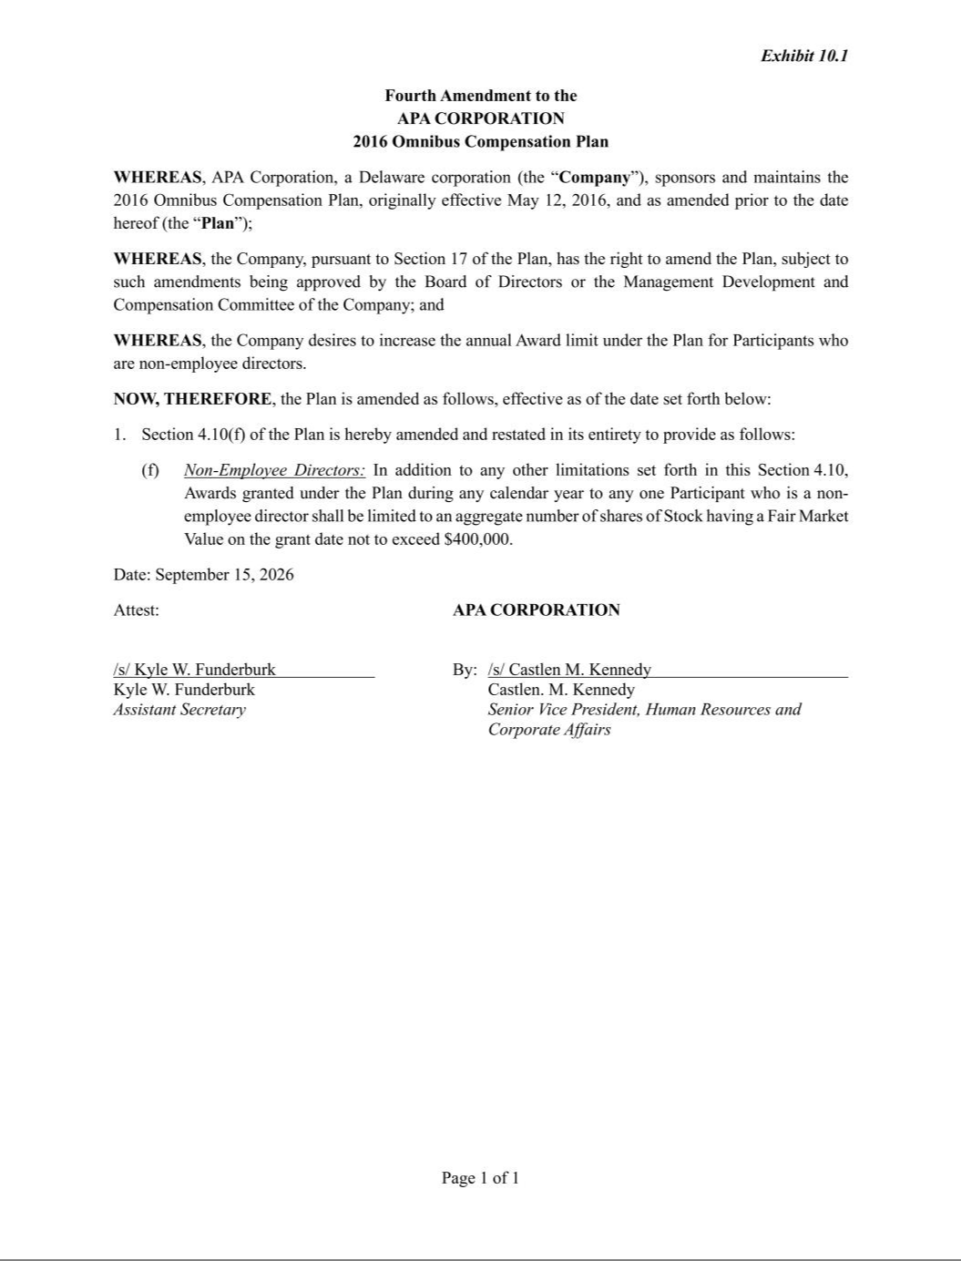

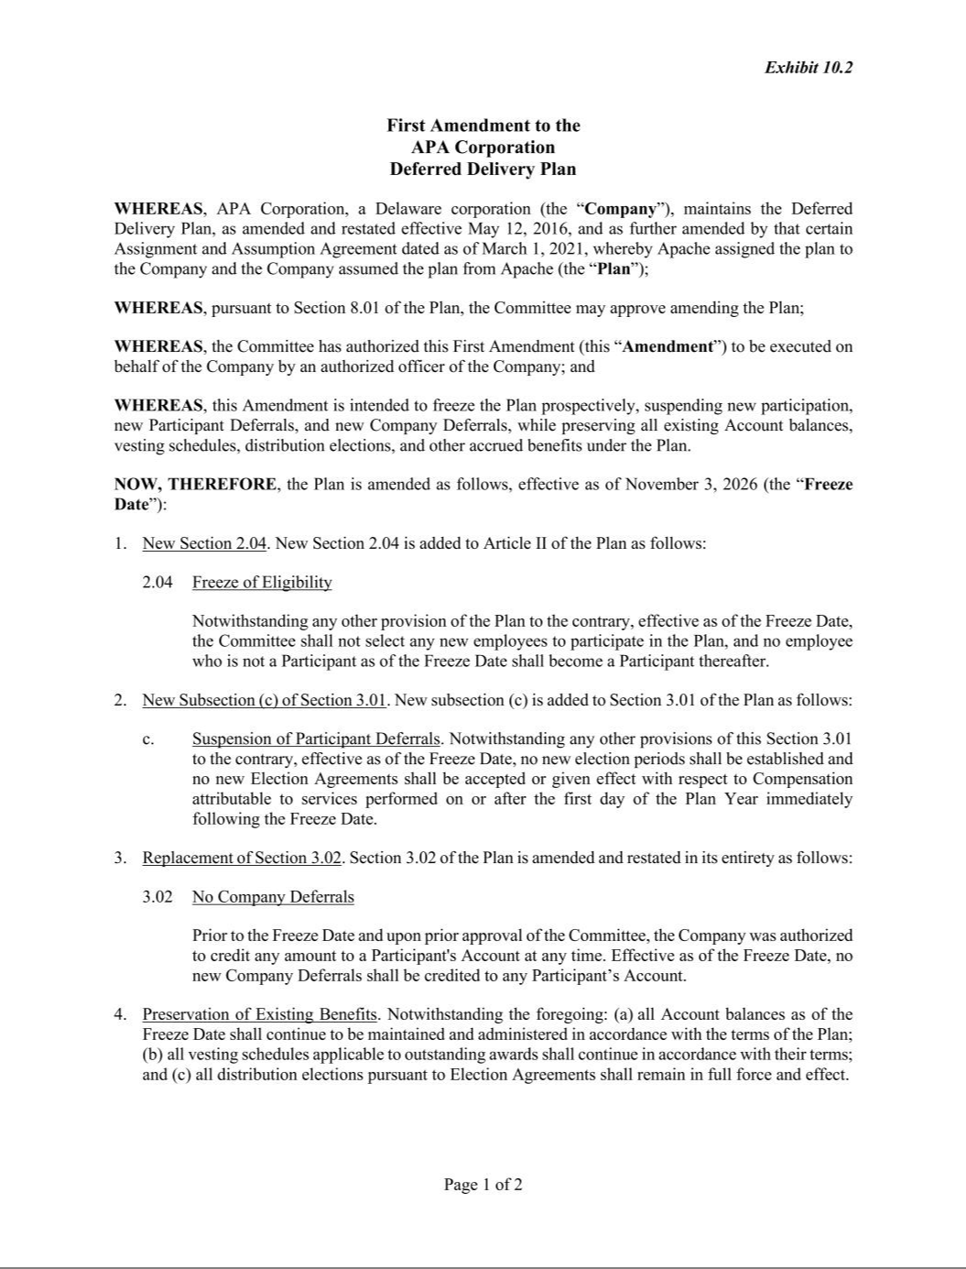

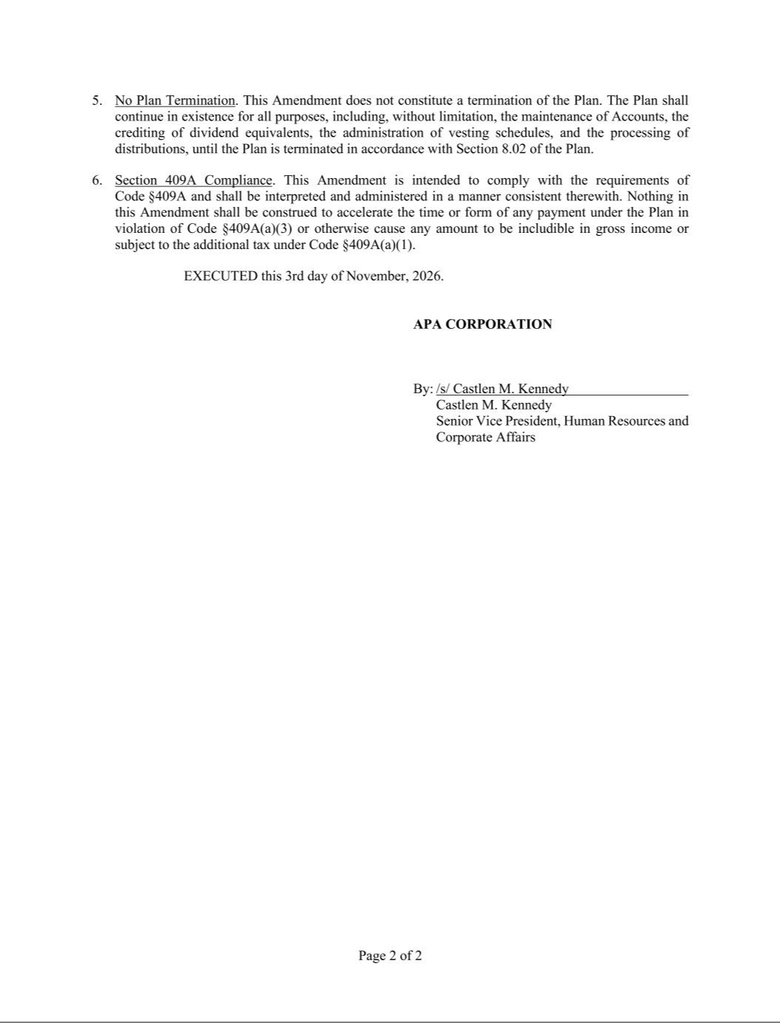

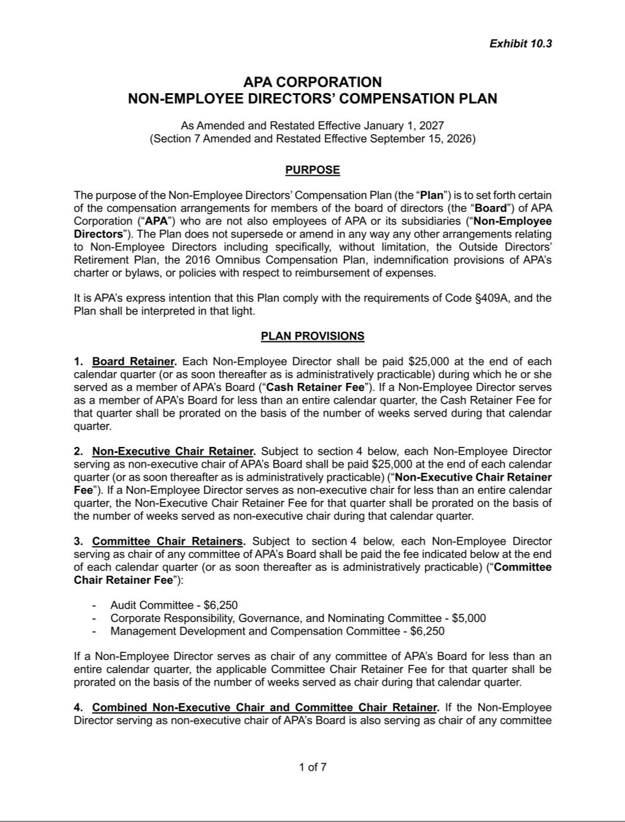

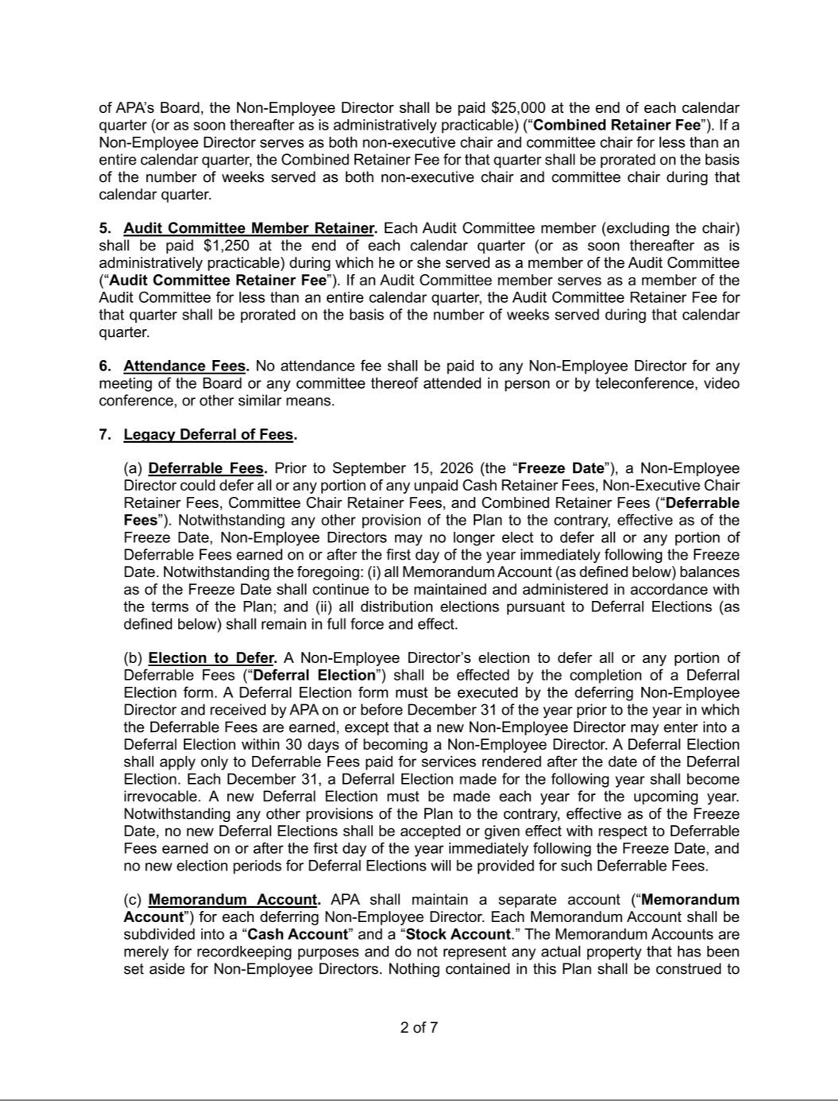

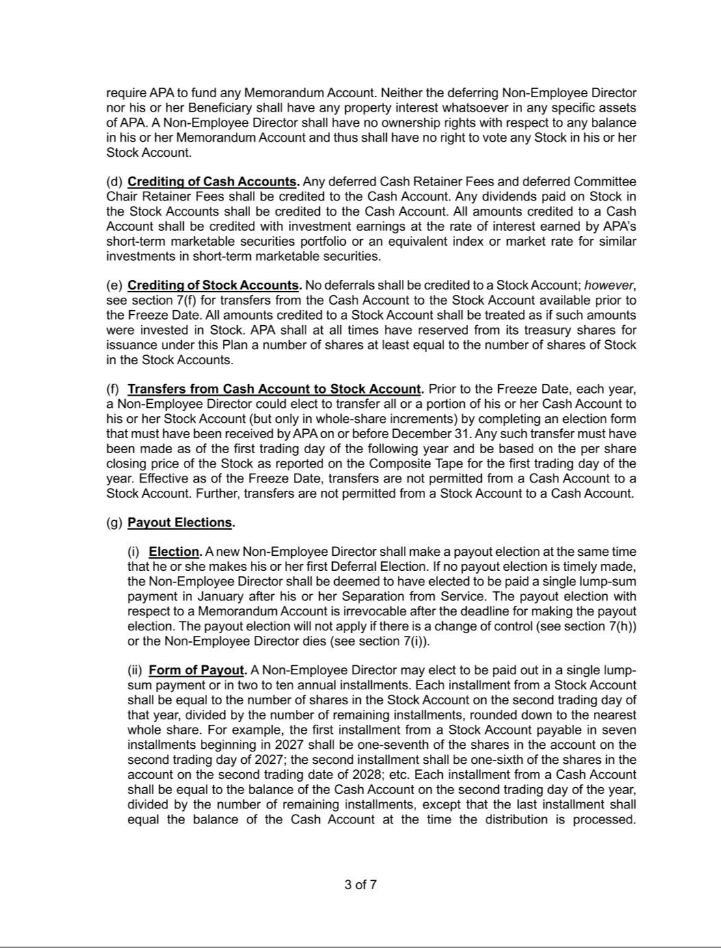

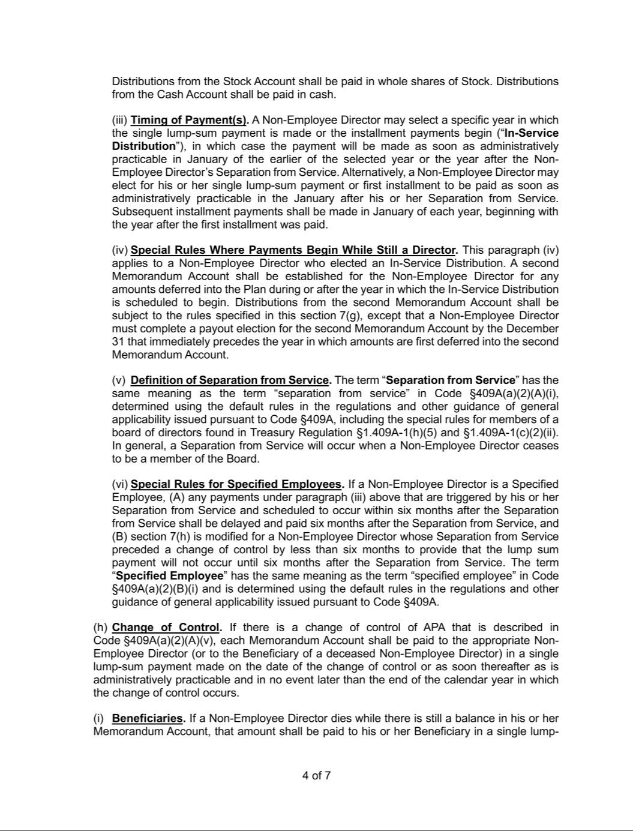

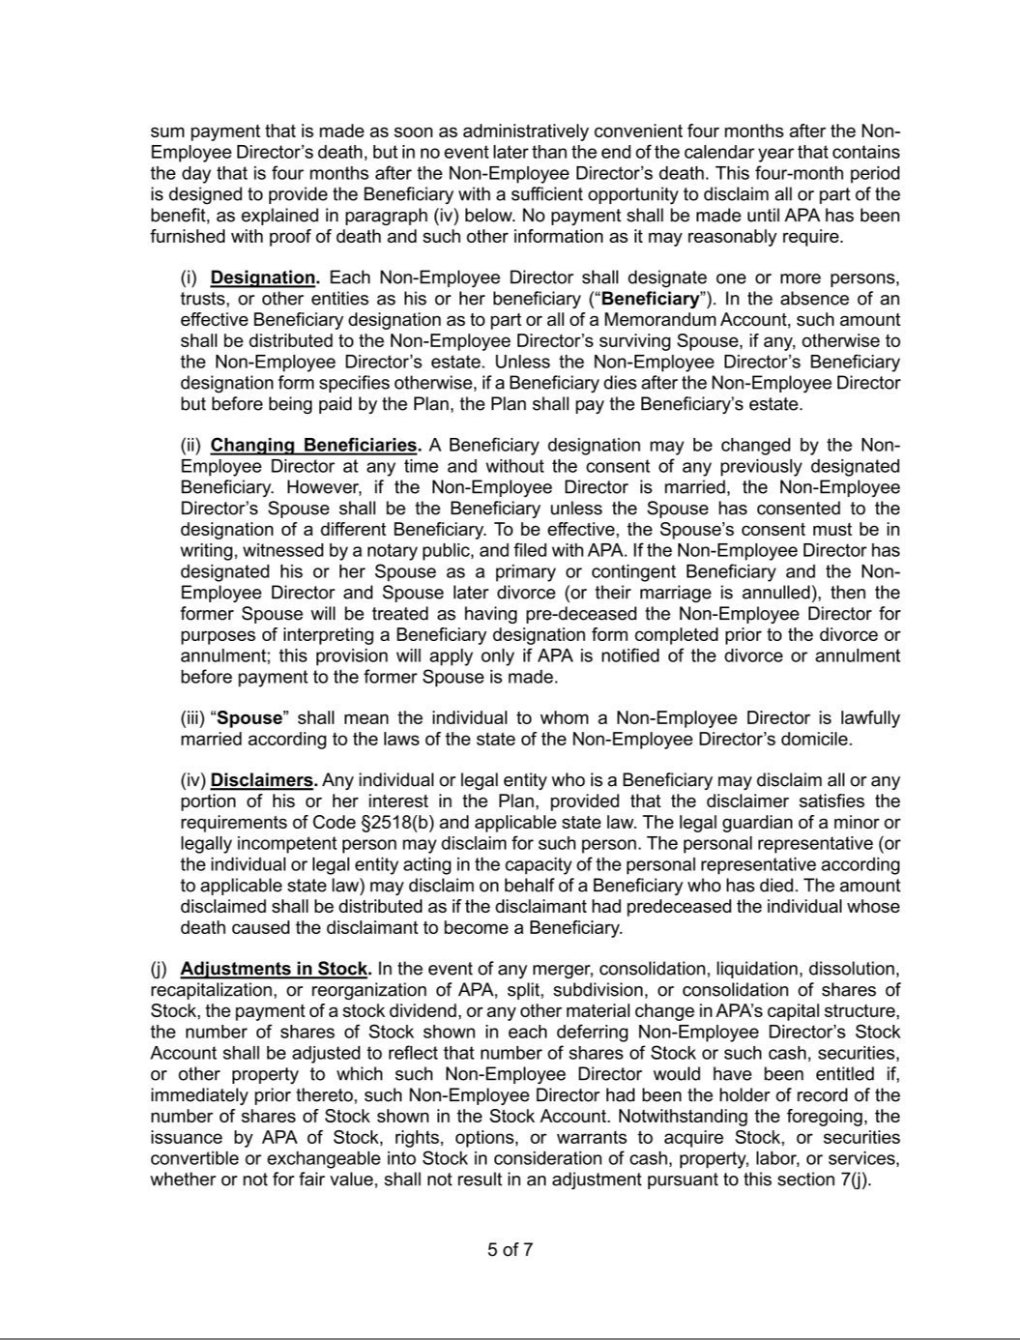

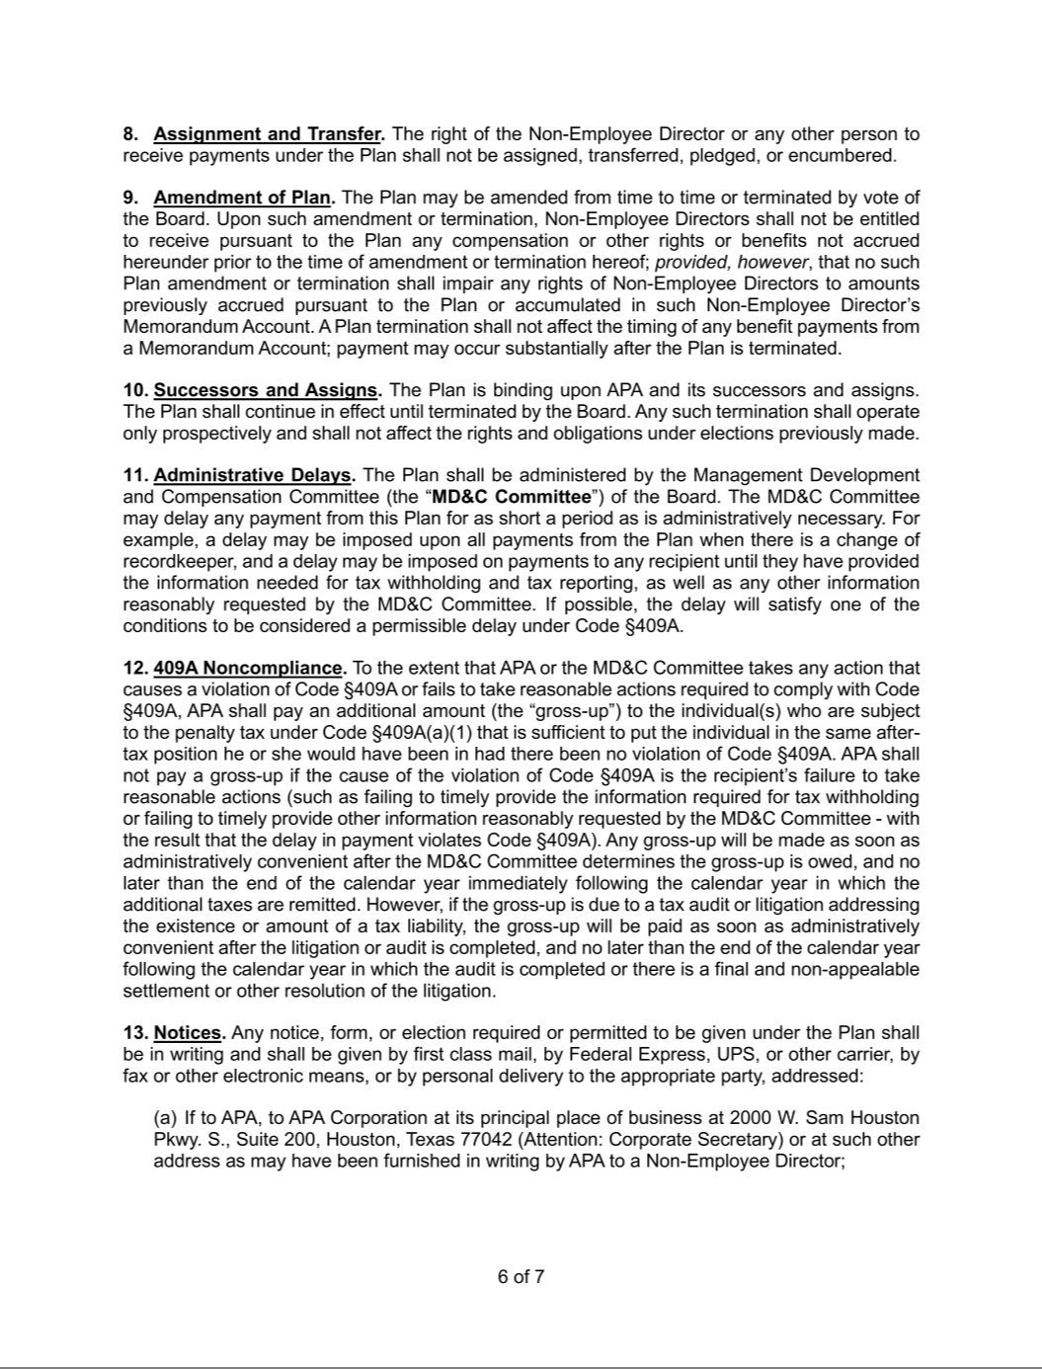

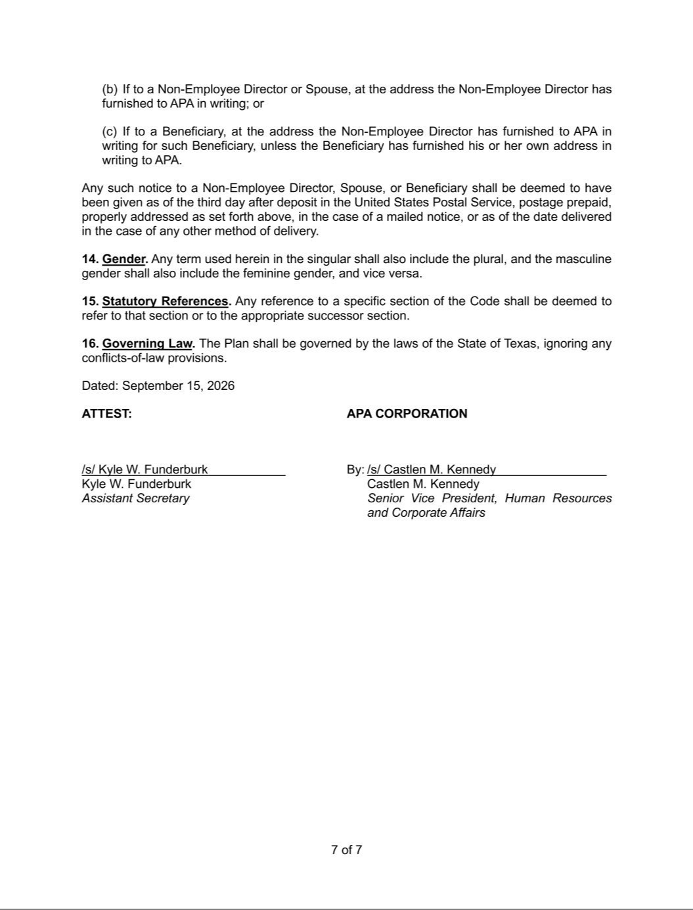

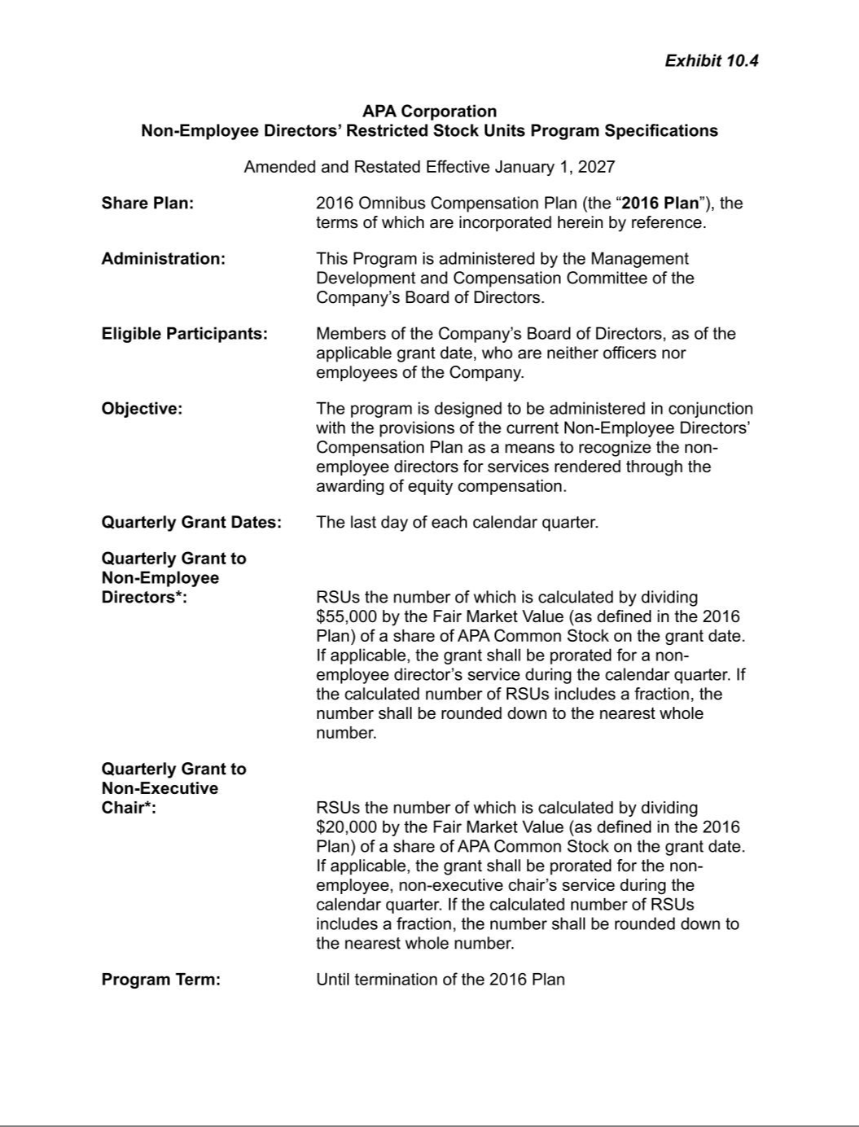

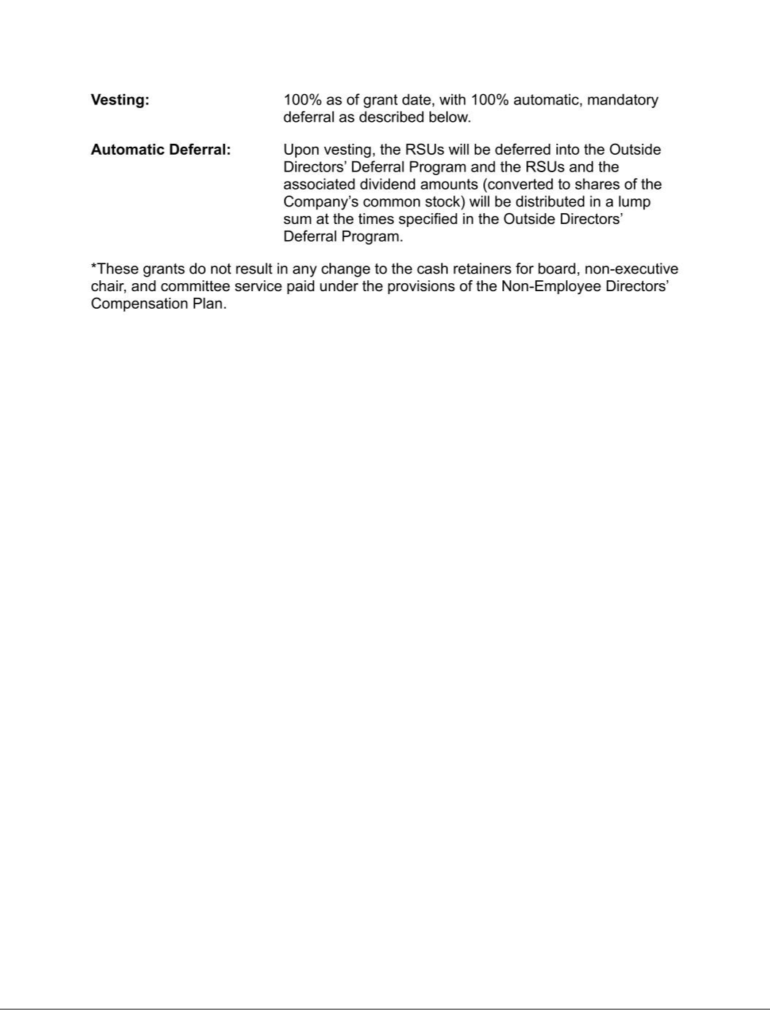

EXHIBIT 31.1

CERTIFICATIONS

I, John J. Christmann IV, certify that:

- I have reviewed this quarterly report on Form 10-Q of APA Corporation;

- Based on my knowledge, this report does not contain any untrue statement of a material fact or omit to state a material fact necessary to make the statements made, in light of the circumstances under which such statements were made, not misleading with respect to the period covered by this report;

- Based on my knowledge, the financial statements, and other financial information included in this report, fairly present in all material respects the financial condition, results of operations and cash flows of the registrant as of, and for, the periods presented in this report;

- The registrant’s other certifying officer and I are responsible for establishing and maintaining disclosure controls and procedures (as defined in Exchange Act Rules 13a-15(e) and 15d-15(e)) and internal control over financial reporting (as defined in Exchange Act Rules 13a-15(f) and 15d-15(f)) for the registrant and have:

  - Designed such disclosure controls and procedures, or caused such disclosure controls and procedures to be designed under our supervision, to ensure that material information relating to the registrant, including its consolidated subsidiaries, is made known to us by others within those entities, particularly during the period in which this report is being prepared;

  - Designed such internal control over financial reporting, or caused such internal control over financial reporting to be designed under our supervision, to provide reasonable assurance regarding the reliability of financial reporting and the preparation of financial statements for external purposes in accordance with generally accepted accounting principles;

  - Evaluated the effectiveness of the registrant’s disclosure controls and procedures and presented in this report our conclusions about the effectiveness of the disclosure controls and procedures, as of the end of the period covered by this report based on such evaluation; and

  - Disclosed in this report any change in the registrant’s internal control over financial reporting that occurred during the registrant’s most recent fiscal quarter (the registrant’s fourth fiscal quarter in the case of an annual report) that has materially affected, or is reasonably likely to materially affect, the registrant’s internal control over financial reporting; and

- The registrant’s other certifying officer and I have disclosed, based on our most recent evaluation of internal control over financial reporting, to the registrant’s auditors and the audit committee of the registrant’s board of directors (or persons performing the equivalent functions):

  - All significant deficiencies and material weaknesses in the design or operation of internal control over financial reporting which are reasonably likely to adversely affect the registrant’s ability to record, process, summarize and report financial information; and

  - Any fraud, whether or not material, that involves management or other employees who have a significant role in the registrant’s internal control over financial reporting.

Date: November 5, 2026

/s/ John J. Christmann IV

John J. Christmann IV

Chief Executive Officer

(Principal Executive Officer)

EXHIBIT 31.2

CERTIFICATIONS

I, Ben C. Rodgers, certify that:

- I have reviewed this quarterly report on Form 10-Q of APA Corporation;

- Based on my knowledge, this report does not contain any untrue statement of a material fact or omit to state a material fact necessary to make the statements made, in light of the circumstances under which such statements were made, not misleading with respect to the period covered by this report;

- Based on my knowledge, the financial statements, and other financial information included in this report, fairly present in all material respects the financial condition, results of operations and cash flows of the registrant as of, and for, the periods presented in this report;

- The registrant’s other certifying officer and I are responsible for establishing and maintaining disclosure controls and procedures (as defined in Exchange Act Rules 13a-15(e) and 15d-15(e)) and internal control over financial reporting (as defined in Exchange Act Rules 13a-15(f) and 15d-15(f)) for the registrant and have:

  - Designed such disclosure controls and procedures, or caused such disclosure controls and procedures to be designed under our supervision, to ensure that material information relating to the registrant, including its consolidated subsidiaries, is made known to us by others within those entities, particularly during the period in which this report is being prepared;

  - Designed such internal control over financial reporting, or caused such internal control over financial reporting to be designed under our supervision, to provide reasonable assurance regarding the reliability of financial reporting and the preparation of financial statements for external purposes in accordance with generally accepted accounting principles;

  - Evaluated the effectiveness of the registrant’s disclosure controls and procedures and presented in this report our conclusions about the effectiveness of the disclosure controls and procedures, as of the end of the period covered by this report based on such evaluation; and

  - Disclosed in this report any change in the registrant’s internal control over financial reporting that occurred during the registrant’s most recent fiscal quarter (the registrant’s fourth fiscal quarter in the case of an annual report) that has materially affected, or is reasonably likely to materially affect, the registrant’s internal control over financial reporting; and

- The registrant’s other certifying officer and I have disclosed, based on our most recent evaluation of internal control over financial reporting, to the registrant’s auditors and the audit committee of the registrant’s board of directors (or persons performing the equivalent functions):

  - All significant deficiencies and material weaknesses in the design or operation of internal control over financial reporting which are reasonably likely to adversely affect the registrant’s ability to record, process, summarize and report financial information; and

  - Any fraud, whether or not material, that involves management or other employees who have a significant role in the registrant’s internal control over financial reporting.

Date: November 5, 2026

/s/ Ben C. Rodgers

Ben C. Rodgers

Executive Vice President and Chief Financial Officer

(Principal Financial Officer)

EXHIBIT 32.1

APA CORPORATION

Certification of Principal Executive Officer

and Principal Financial Officer

I, John J. Christmann IV, certify pursuant to 18 U.S.C. Section 1350, as adopted pursuant to Section 906 of the Sarbanes-Oxley Act of 2002, that, to my knowledge, the quarterly report on Form 10-Q of APA Corporation for the quarterly period ending September 30, 2026, fully complies with the requirements of Section 13(a) or 15(d) of the Securities Exchange Act of 1934 (15 U.S.C. §78m or §78o (d)) and that information contained in such report fairly represents, in all material respects, the financial condition and results of operations of APA Corporation.

Date: November 5, 2026

/s/ John J. Christmann IV

By: | John J. Christmann IV
Title: | Chief Executive Officer
 | (Principal Executive Officer)

I, Ben C. Rodgers, certify pursuant to 18 U.S.C. Section 1350, as adopted pursuant to Section 906 of the Sarbanes-Oxley Act of 2002, that, to my knowledge, the quarterly report on Form 10-Q of APA Corporation for the quarterly period ending September 30, 2026, fully complies with the requirements of Section 13(a) or 15(d) of the Securities Exchange Act of 1934 (15 U.S.C. §78m or §78o (d)) and that information contained in such report fairly represents, in all material respects, the financial condition and results of operations of APA Corporation.

Date: November 5, 2026

/s/ Ben C. Rodgers

By: | Ben C. Rodgers
Title: | Executive Vice President and Chief Financial Officer
 | (Principal Financial Officer)

